**Dev_Setup**

#Tasks:

Question 1

Select Your Operating System (OS): Choose an operating system that best suits your preferences and project requirements. Download and Install Windows 11. <https://www.microsoft.com/software-download/windows11>

I couldn’t install and Update to Windows 11 but I do have the latest OS before Windows 11 and all the software was compatible to me to download.

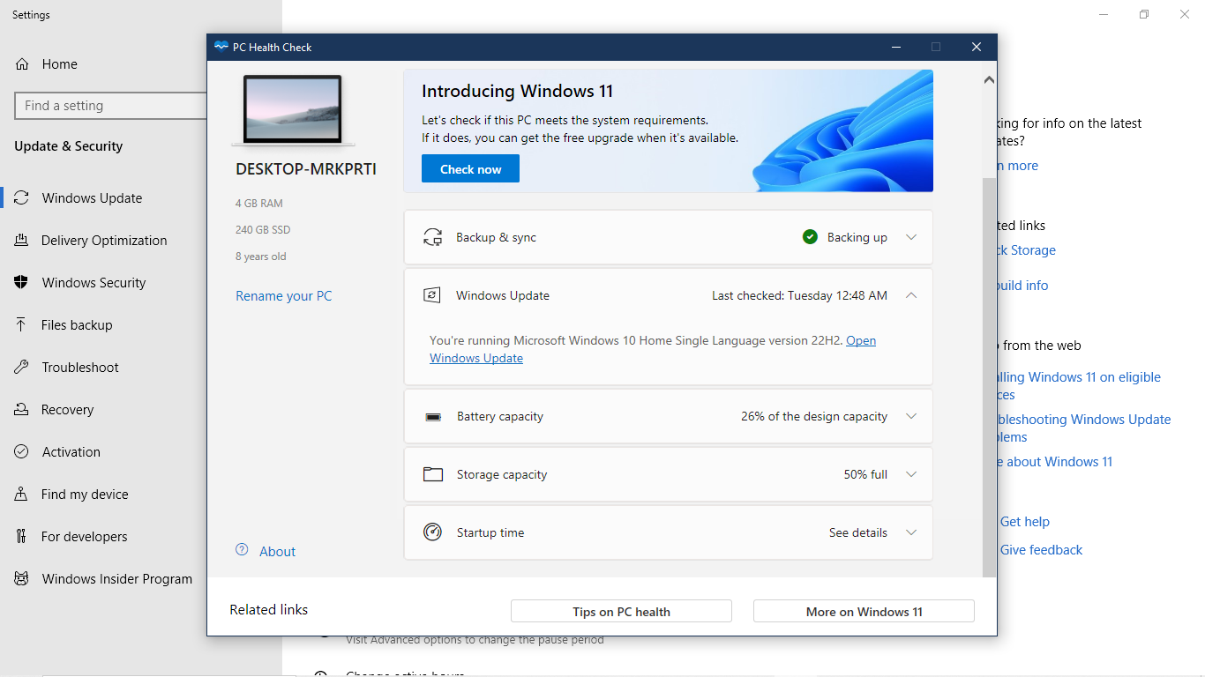

Question 2

Install a Text Editor or Integrated Development Environment (IDE): Select and install a text editor or IDE suitable for your programming languages and workflow. Download and Install Visual Studio Code. <https://code.visualstudio.com/Download>

Step 1:

Click the link that was given therefore it will link you to the website “Visual Studio Code” Download page <https://code.visualstudio.com/Download>, if it doesn’t work, use your preferred browser and search “Download visual studio code” click on this image below:

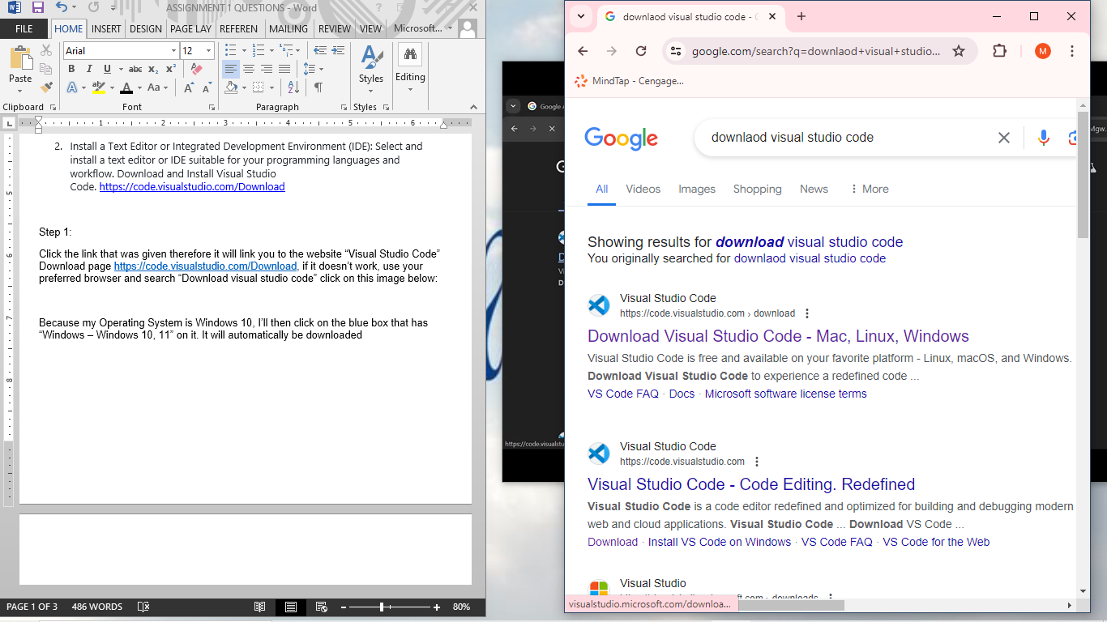

Step 2:

Because my Operating System is Windows 10, I’ll then click on the blue box that has “Windows – Windows 10, 11” on it. It will automatically be downloaded

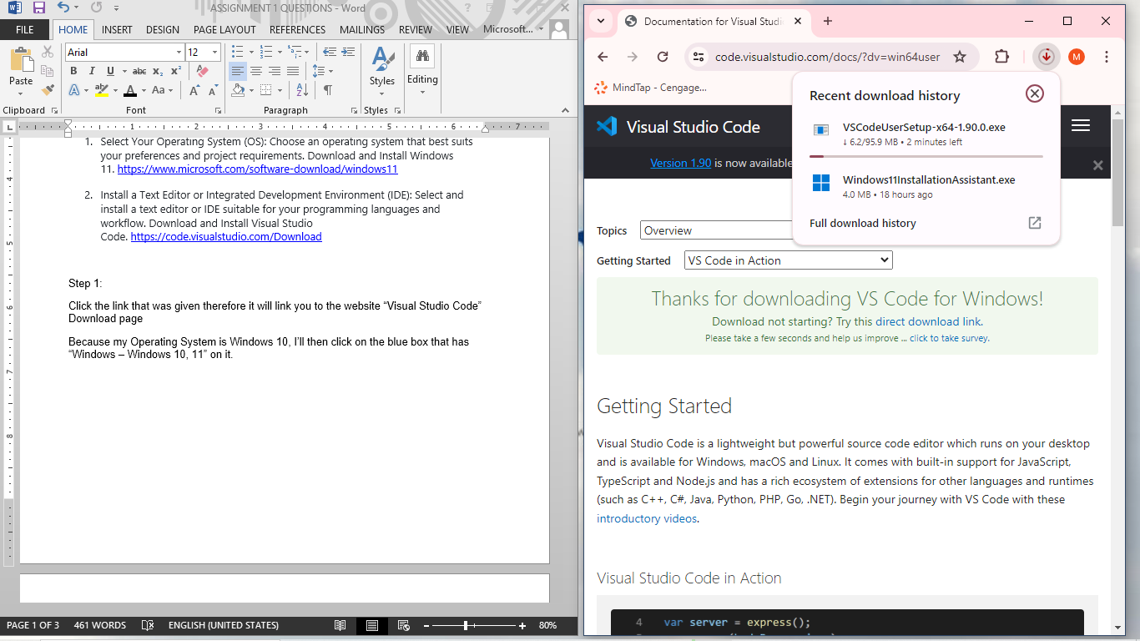

Step 3:

Click on open folder then on your downloads you will right click and “run as administrator”

Step 4:

Then it will lead you to the setup menu then you:

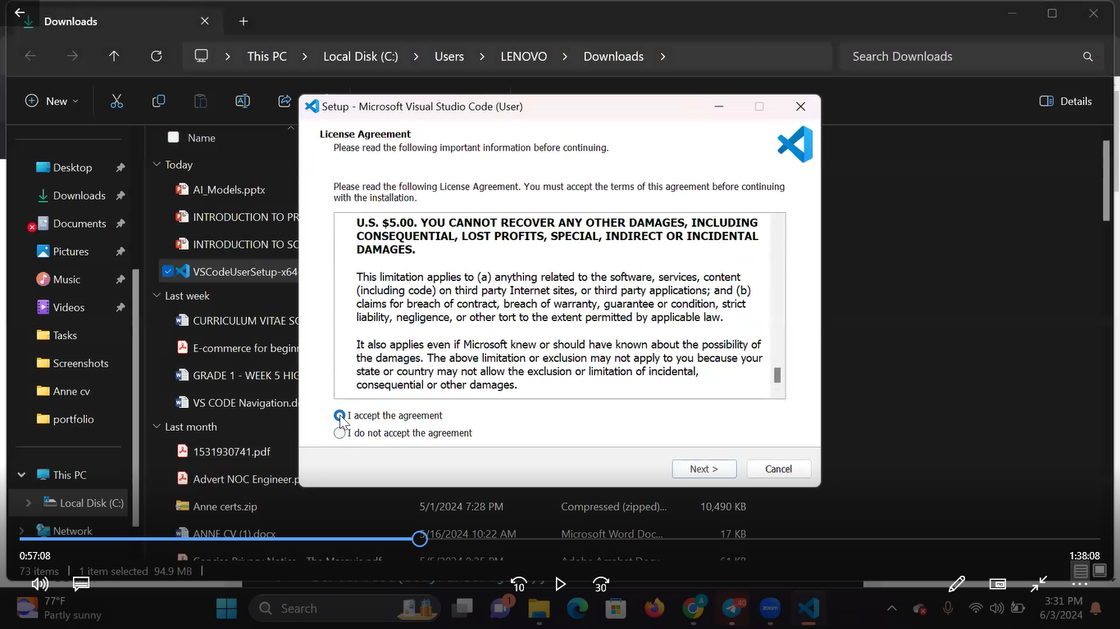

Step 5: Then you will click on” I accept button then “next”

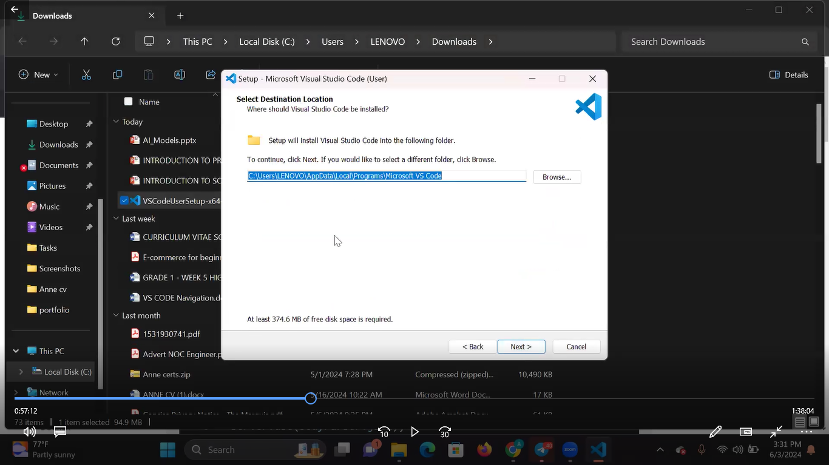

Step 6: It will lead you to a next page which will have a default file path for you and then you just enter “Next”

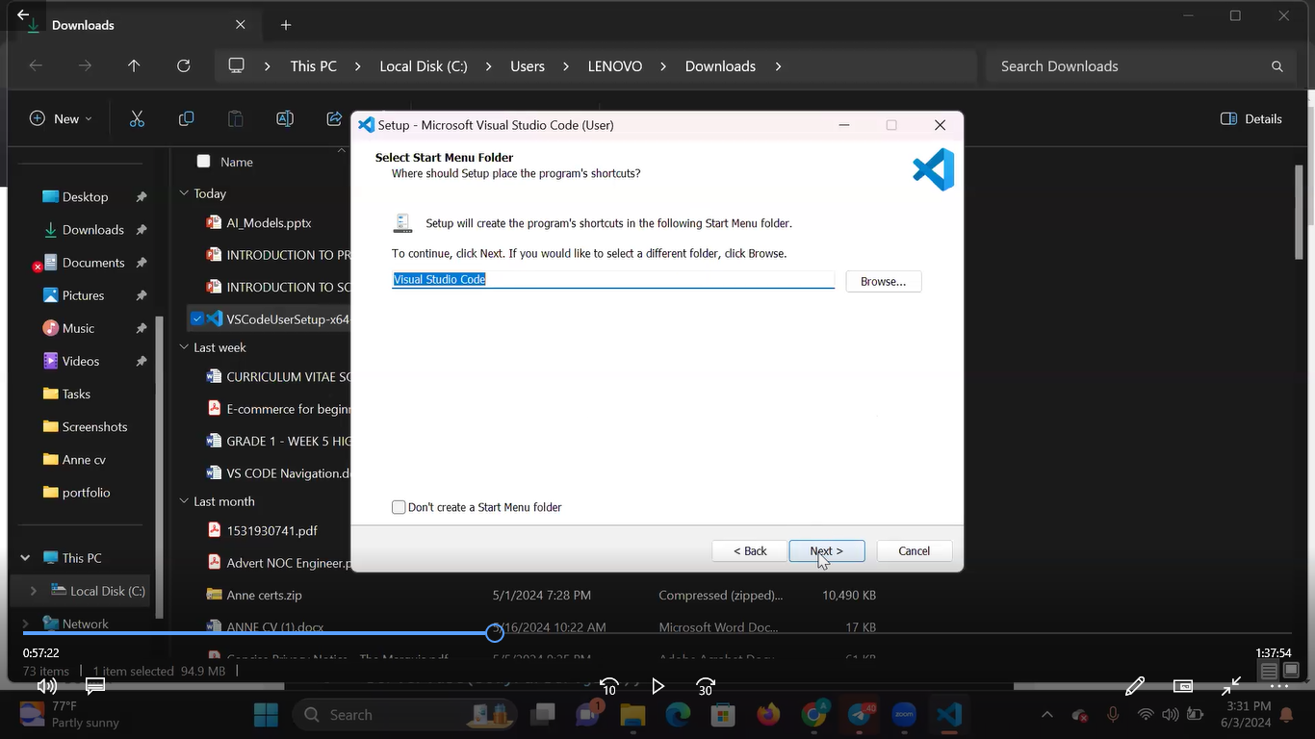

Step 7: Select Smart Folder

Don’t click anything just Click “Next”.

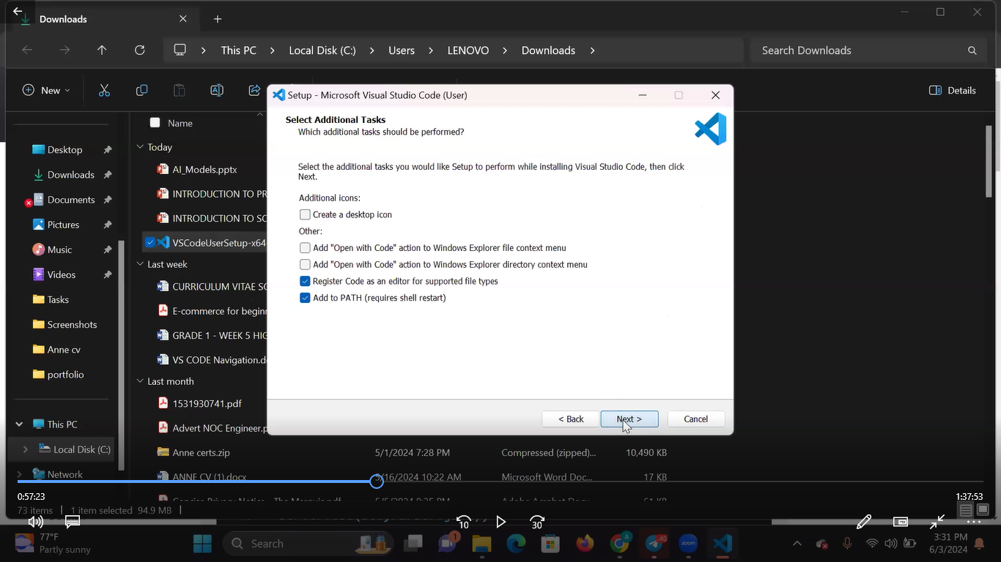

Step 8: Select Additional Tasks

Tick all boxes then click “Next”.

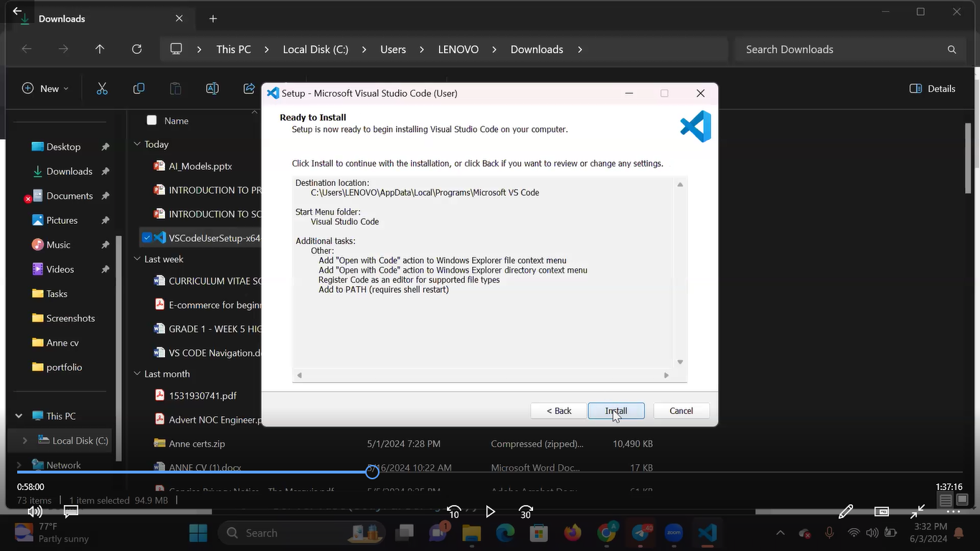

Step 9: Ready to Install

Click “Install”

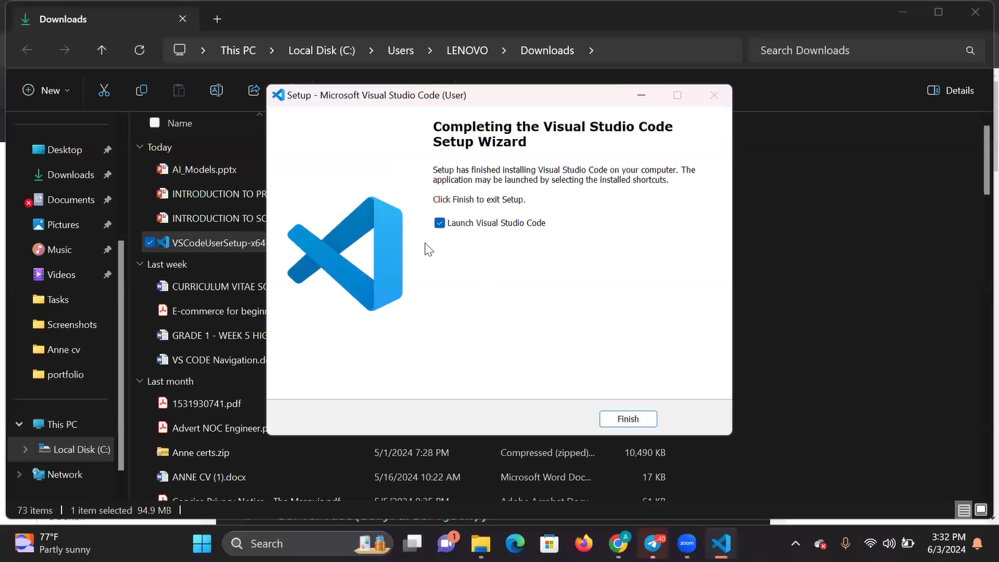

Step 10: After it has installed it will bring us to this page then click “Finish”

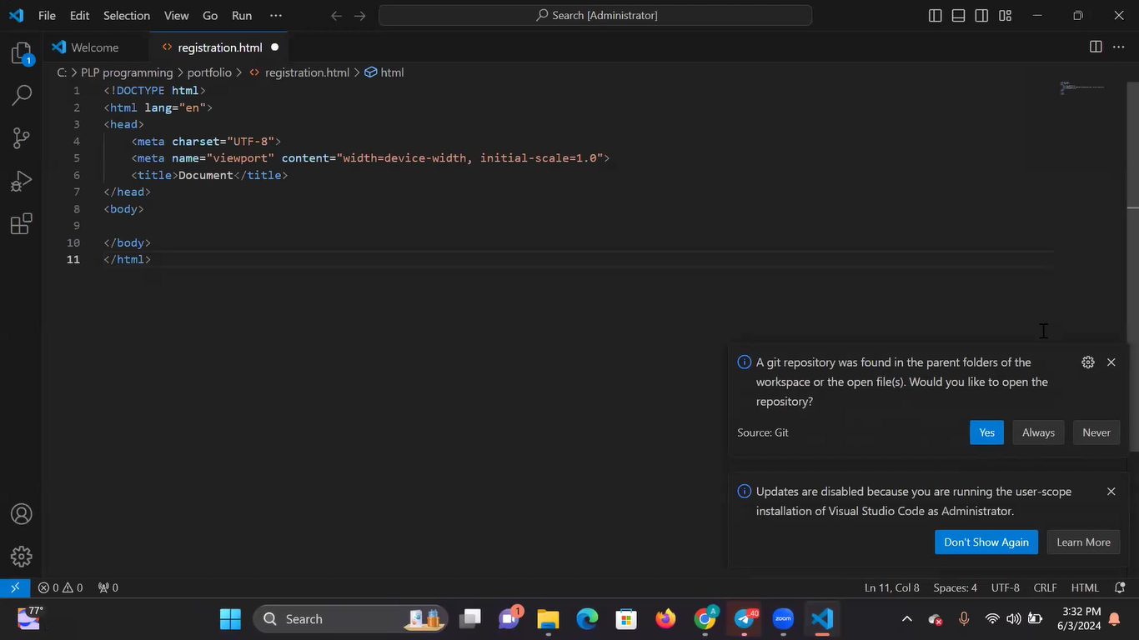

Step 11: Then the application will now launch

Question 3

Set Up Version Control System: Install Git and configure it on your local machine. Create a GitHub account for hosting your repositories. Initialize a Git repository for your project and make your first commit. [https://github.com](https://github.com/)

Step 1:

Search “Git” then go to the website:

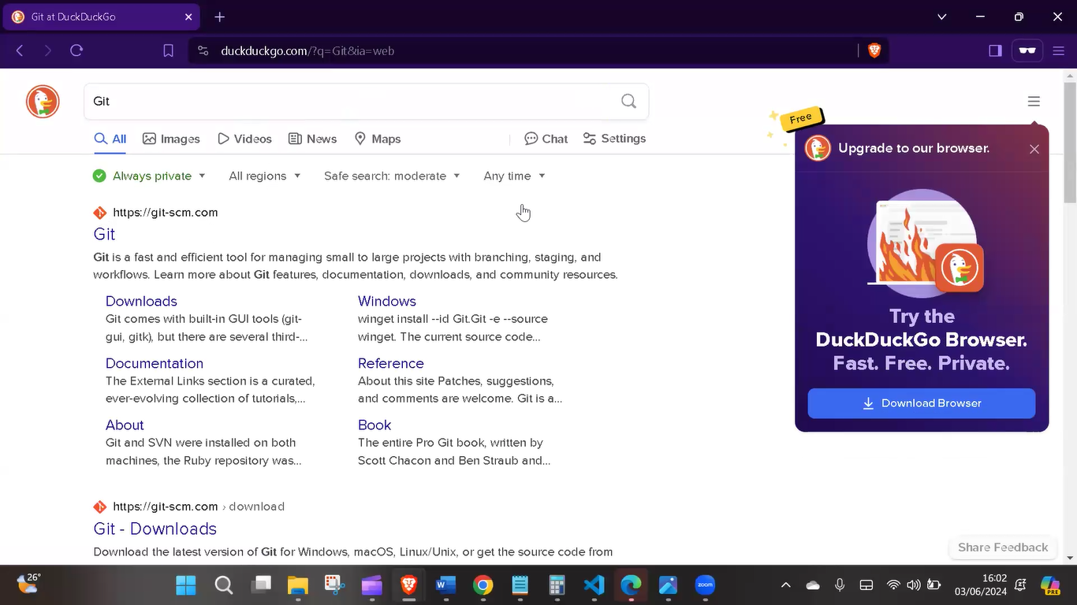

Step 2: Then click the website above

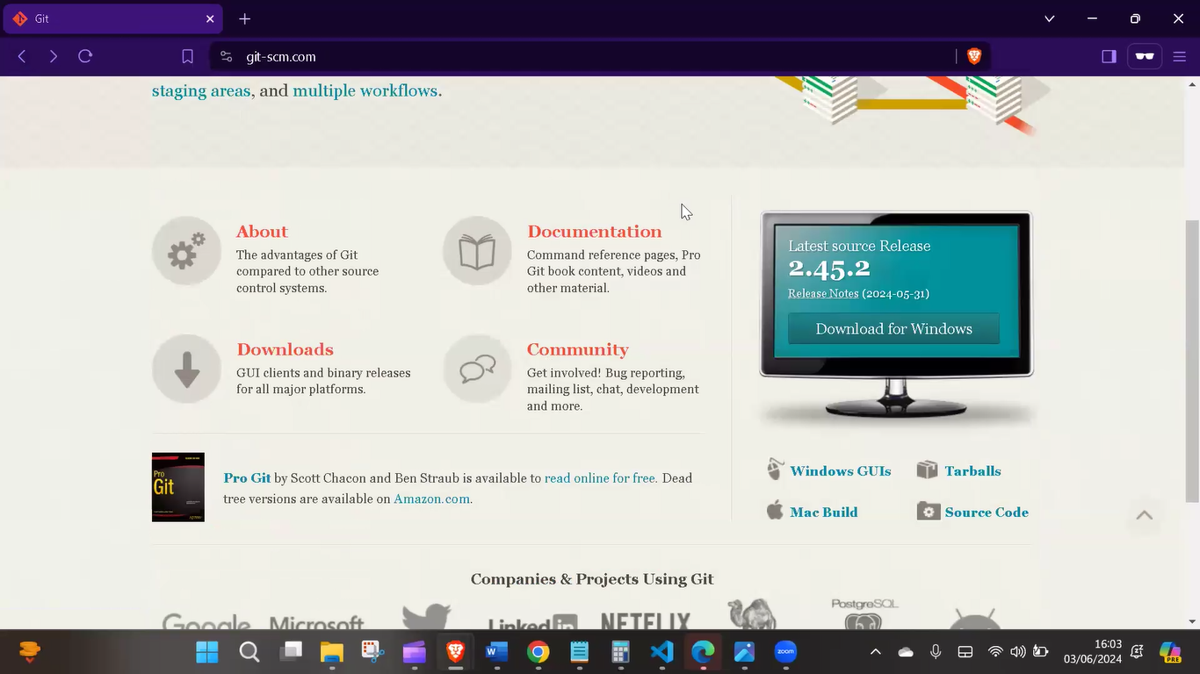

Step 3: Then scroll on the page until you find this image above then click on download

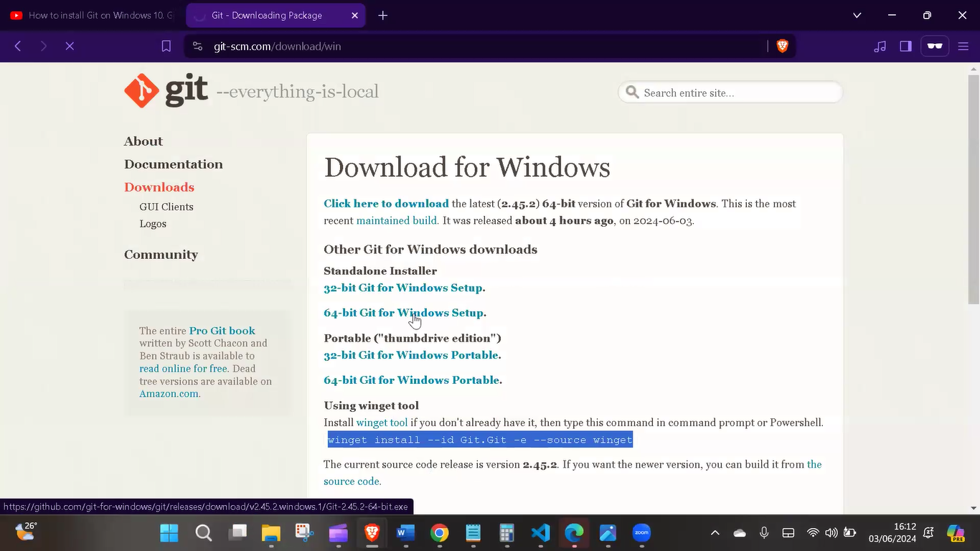

Step 4: Clicked on the Operating System I use then it will download it.

Step 5: Click on the downloaded folder then it will lead me to the Git Setup

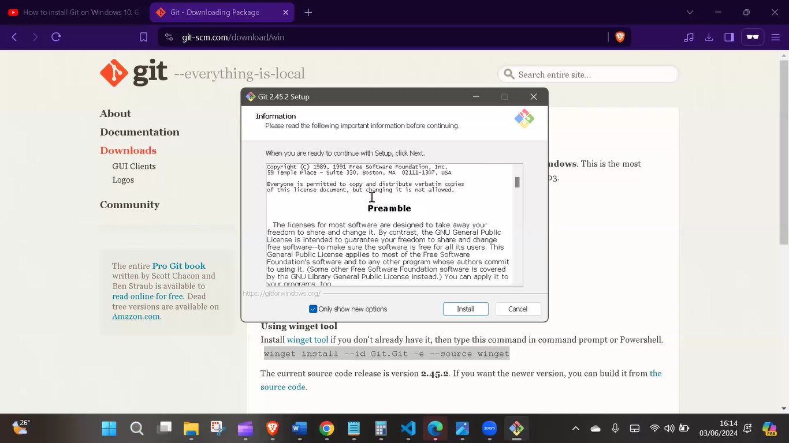

Step 6: Click Install, then after installation I click “Finish” Then Git and Gitbash is installed.

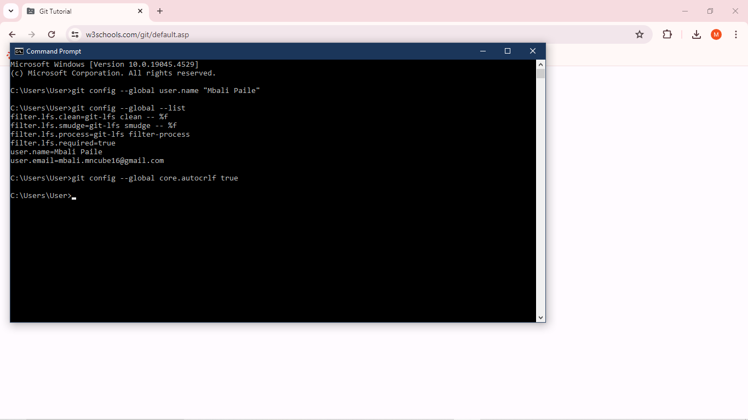How I configured my git to my local server:

Step 1: I typed ‘git config –global user.name “my name” ‘

Step 2: Then I typed ‘config –global core.autocrlf true’

Then it has been configured!

Now how do I create a GitHub account for hosting my repositories?

Step 1: Access GitHub by opening my web browser and navigate to the GitHub website. Github.com

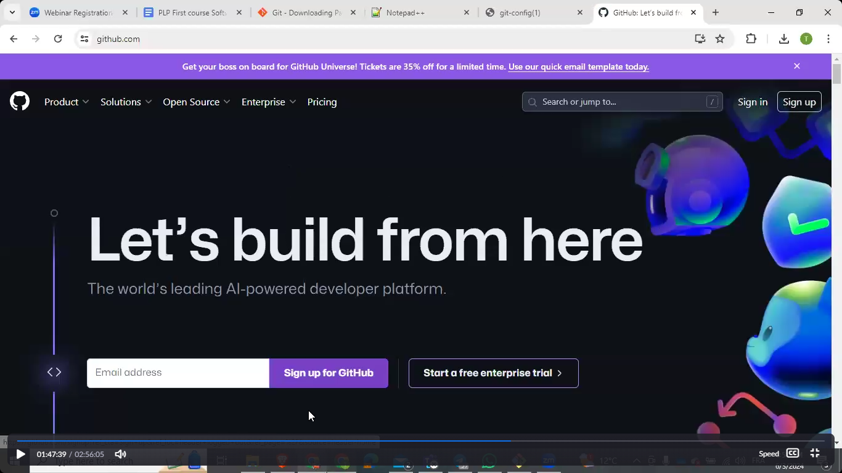

Step 2: Click on Sign up

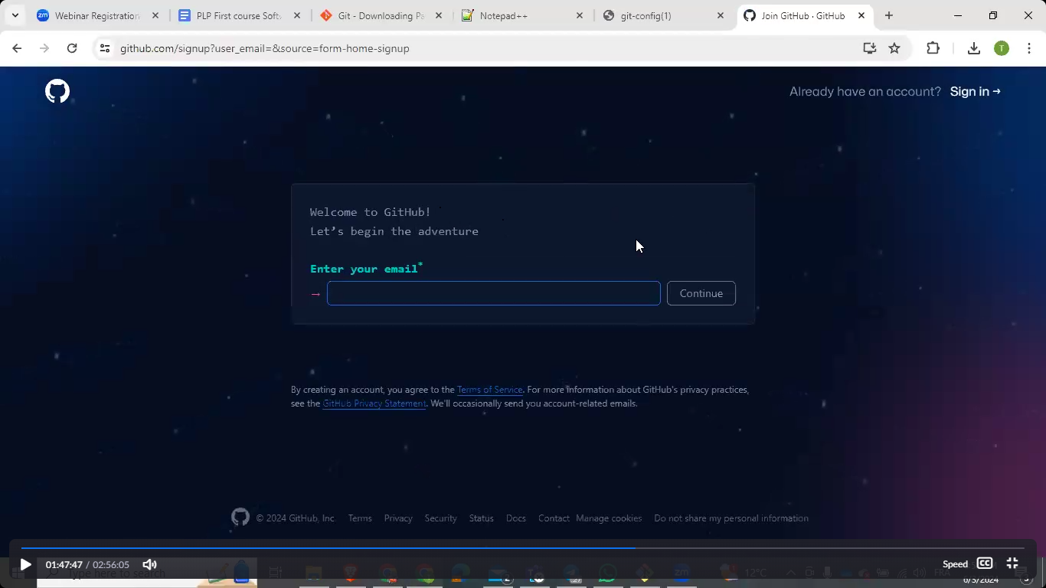

Step 3: enter my email

Step 4: Got a verification code from my email address

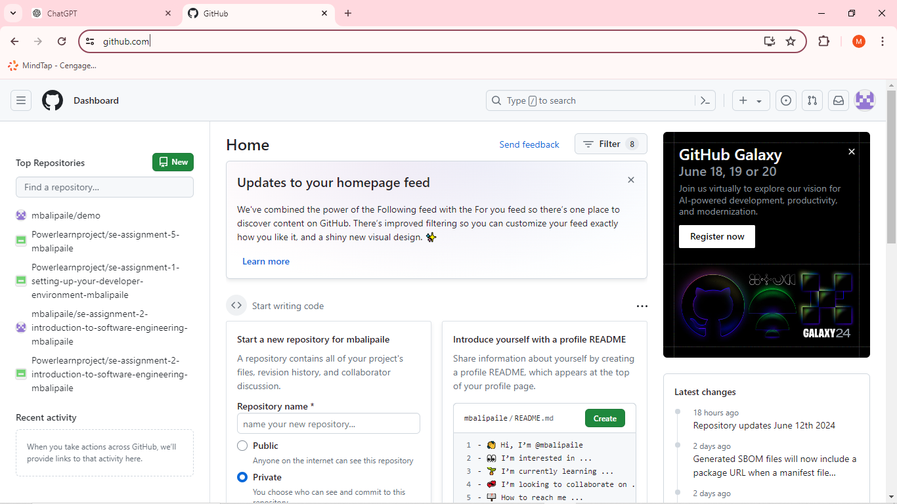

Step 5: Then my Github is made.

Question 4

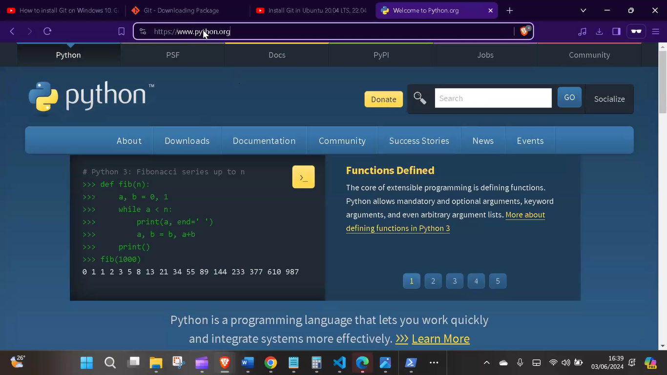Install Necessary Programming Languages and Runtimes: Install Python from [http://wwww.python.org](http://wwww.python.org/) programming language required for your project and install their respective compilers, interpreters, or runtimes. Ensure you have the necessary tools to build and execute your code.

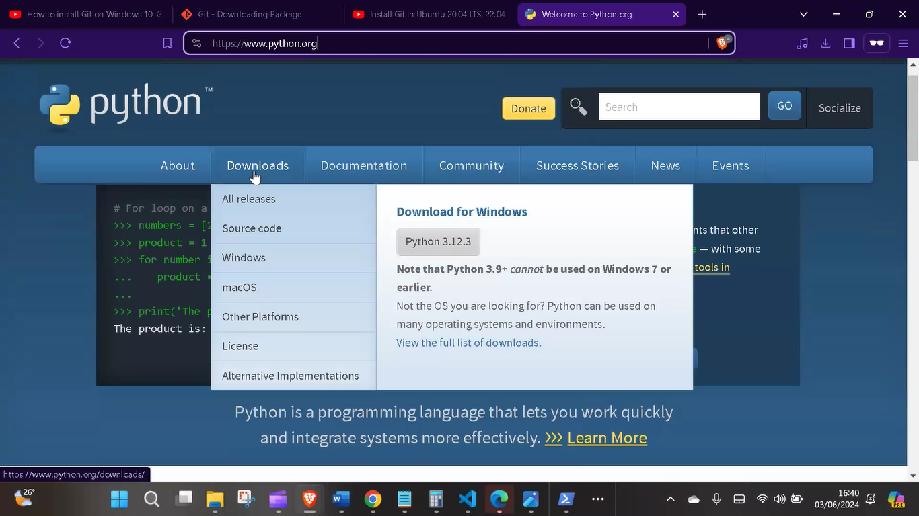Step 1: Clicked on the link [http://wwww.python.org](http://wwww.python.org/)

Step 2: Clicked on “Python 3.12.3”.

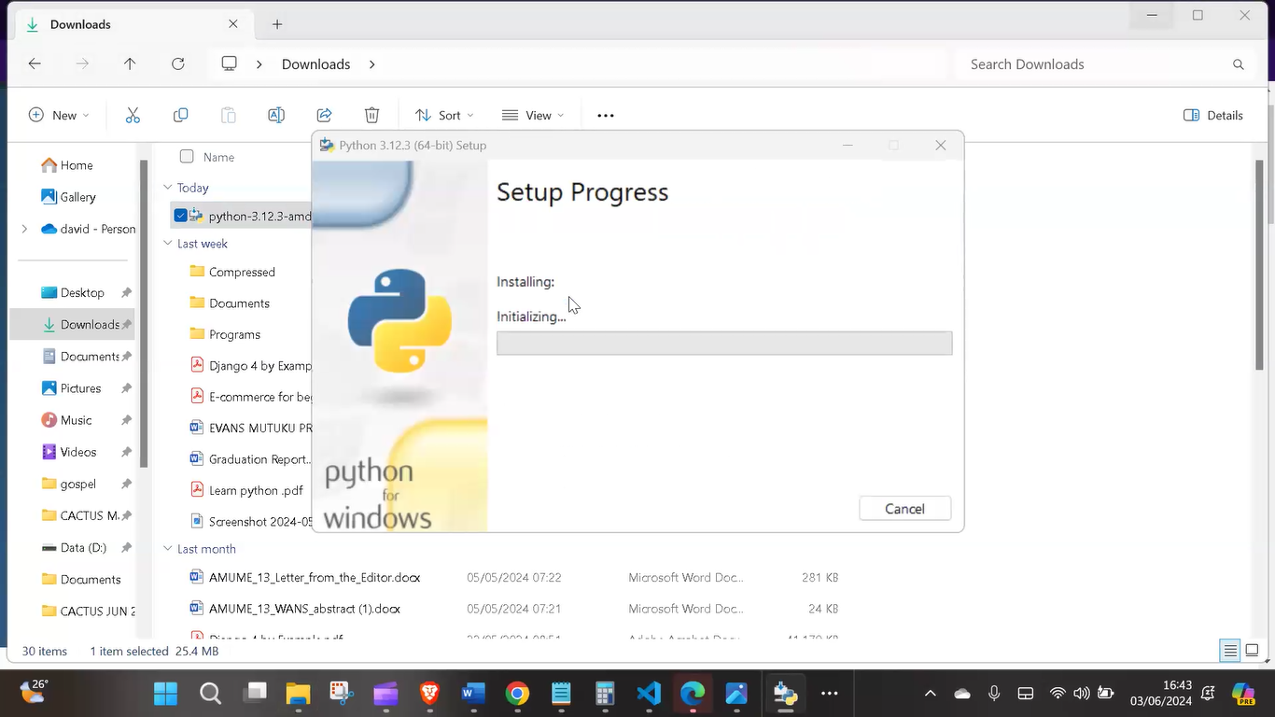

Step 3: Selected “Install” and began installing thereafter finally installed.

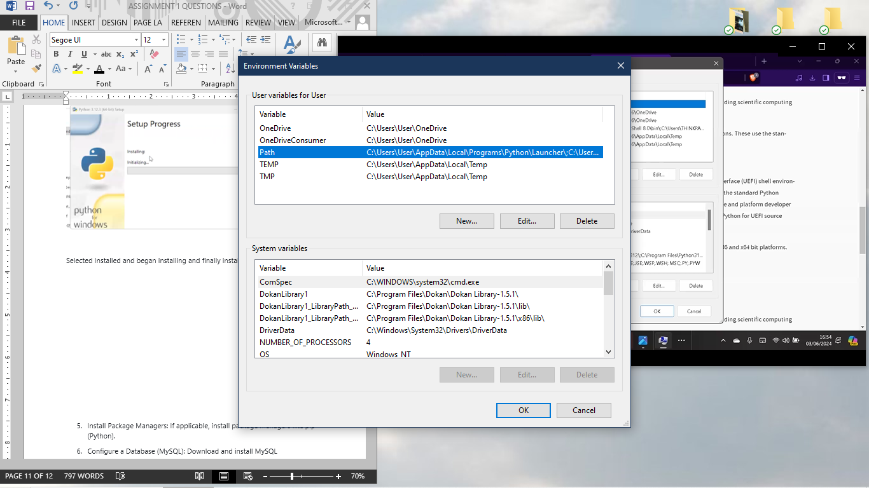

Step 4: Making sure that Python is in my path in the environment variable. Now all done!

Question 5

Install Package Managers: If applicable, install package managers like pip (Python).

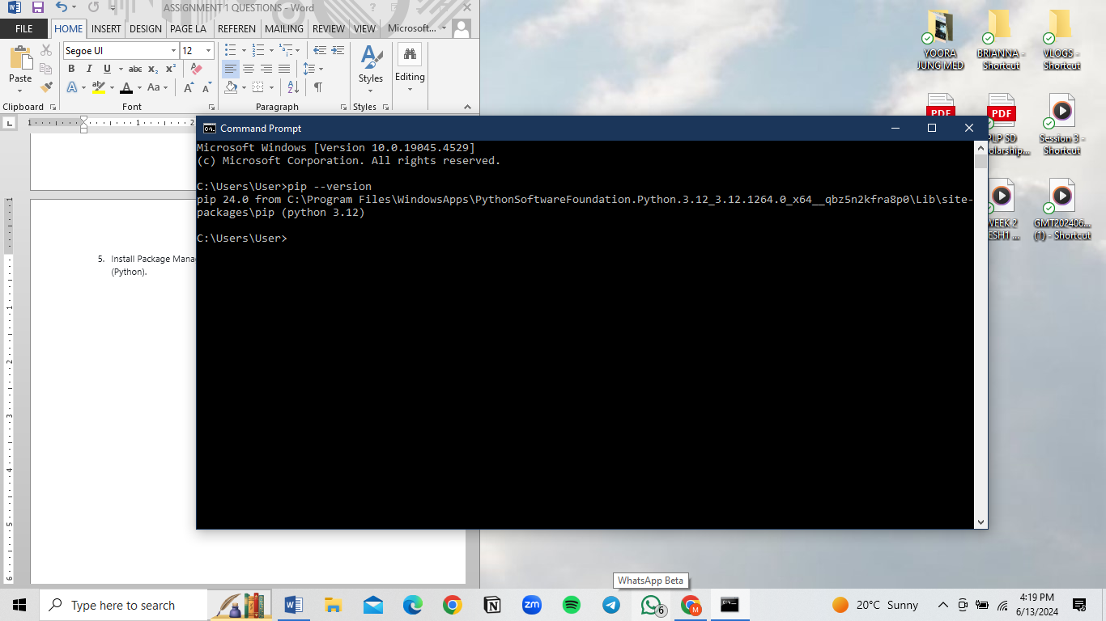Step 1: I used the command on my command prompt is python get –pip.py

Step 2: I typed the command pip –version to check if it was properly installed.

Question 6

Configure a Database (MySQL): Download and install MySQLdatabase. <https://dev.mysql.com/downloads/windows/installer/5.7.html>

Step 1:

I clicked this link <https://dev.mysql.com/downloads/windows/installer/5.7.html> then chose the one appropriate for my operating system. I kept downloading the application which was not appreciate for my operating system which couldn’t work, till I realized I needed the one right for my laptop and downloaded the right one.

Step 2:

I moved the folder from my downloads to my local file then after run the application set up and a wizard popped up.

Step 3: I then clicked on Server only then ne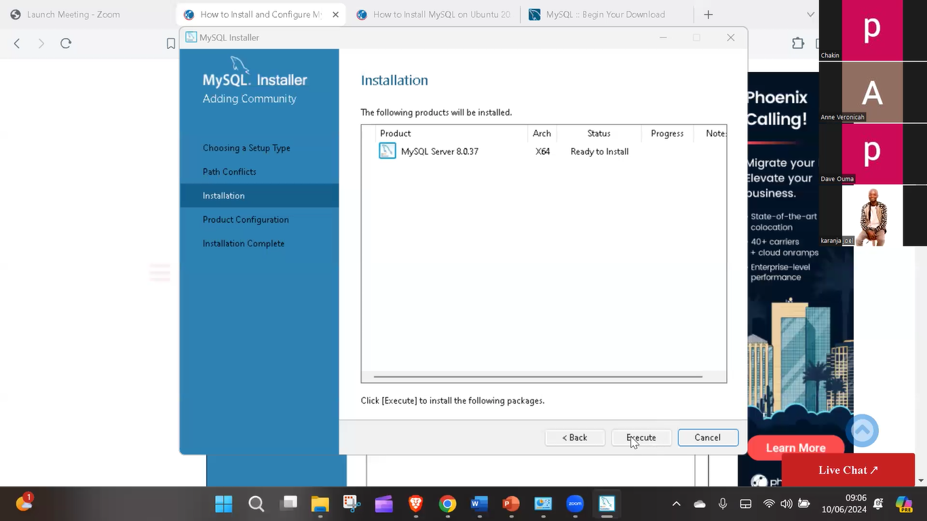xt

Step 4: Then after I choose the latest application to install then execute

Step 5: under product configuration, I still click next

Step 6: Then under Type and Networking I clicked “Development Computer” from config type and tick “Named Page” and “Shared Memory” and “Show Advanced and Logging Options”

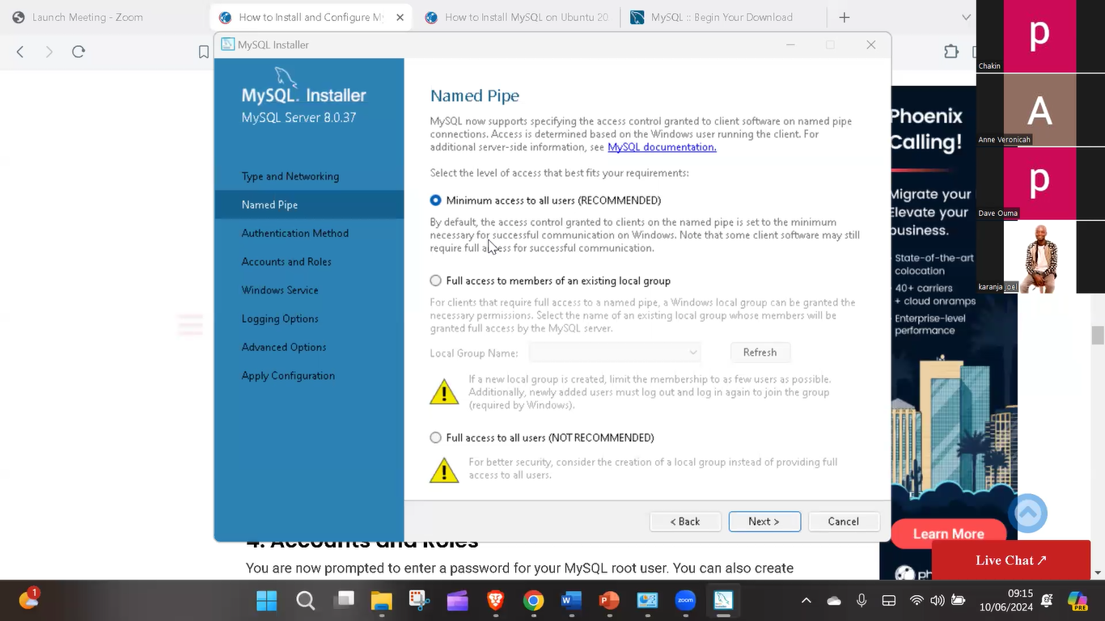

Step 7: Then under Named Pipe I choose the Minimum access to all users (RECOMMENDED), then next.

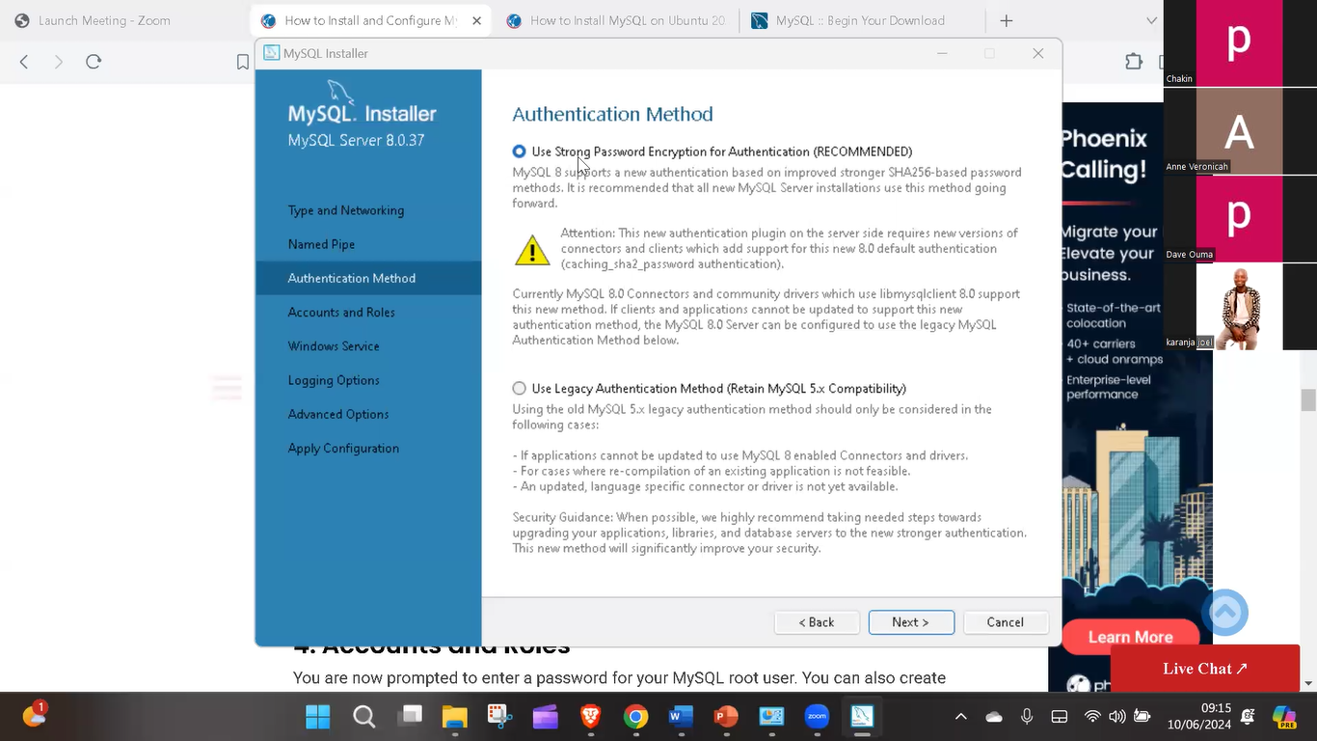

Step 8: then after the “Under Authentication” page I chose the first box then after next (The recommended one)

Step 9: Then after I added my new password onto “MySQL Root Password” and thereafter retype it onto repeat password and click next

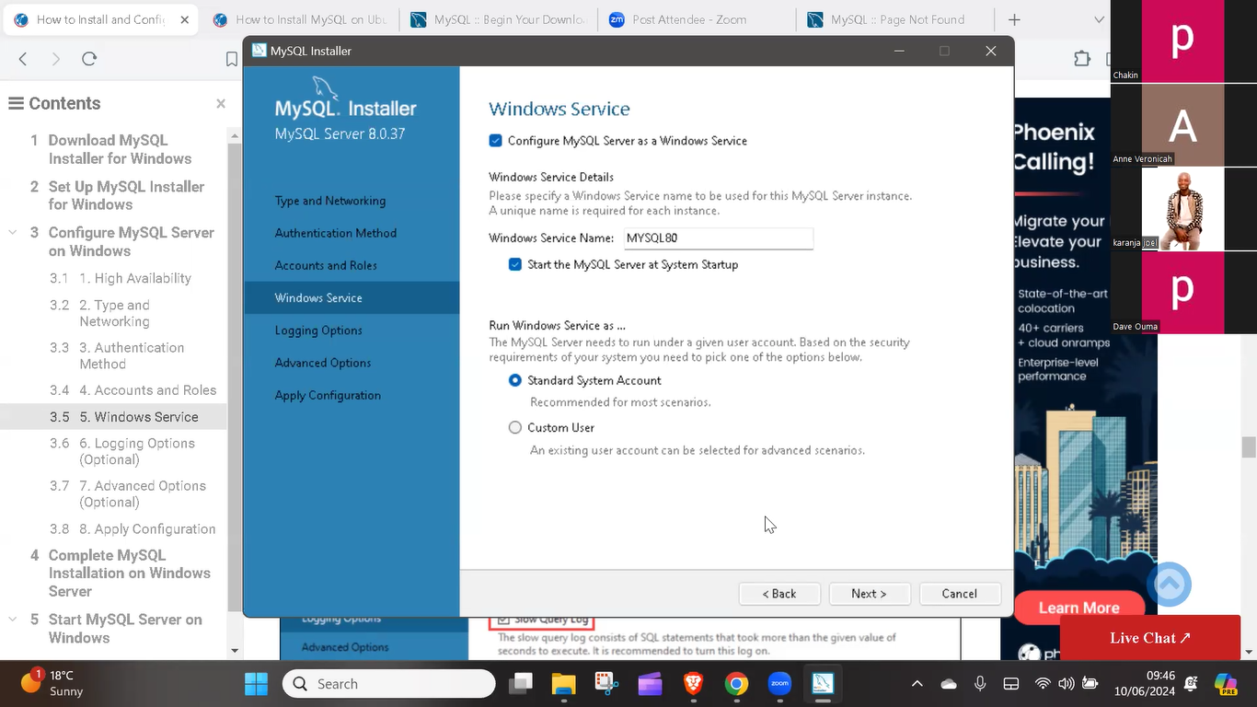

Step 10: I make sure to click “Configure MySQL Server” as a Windows service and also the box “Start the MySQL Server at System Startup “and click “Standard System Account” and click Next.

Step 11: Then on the Logging Option page I click the boxes “Slow Query Log” and “Binary Log” then next.

Step 12: I simply just click next under the “Advanced Options Page”.

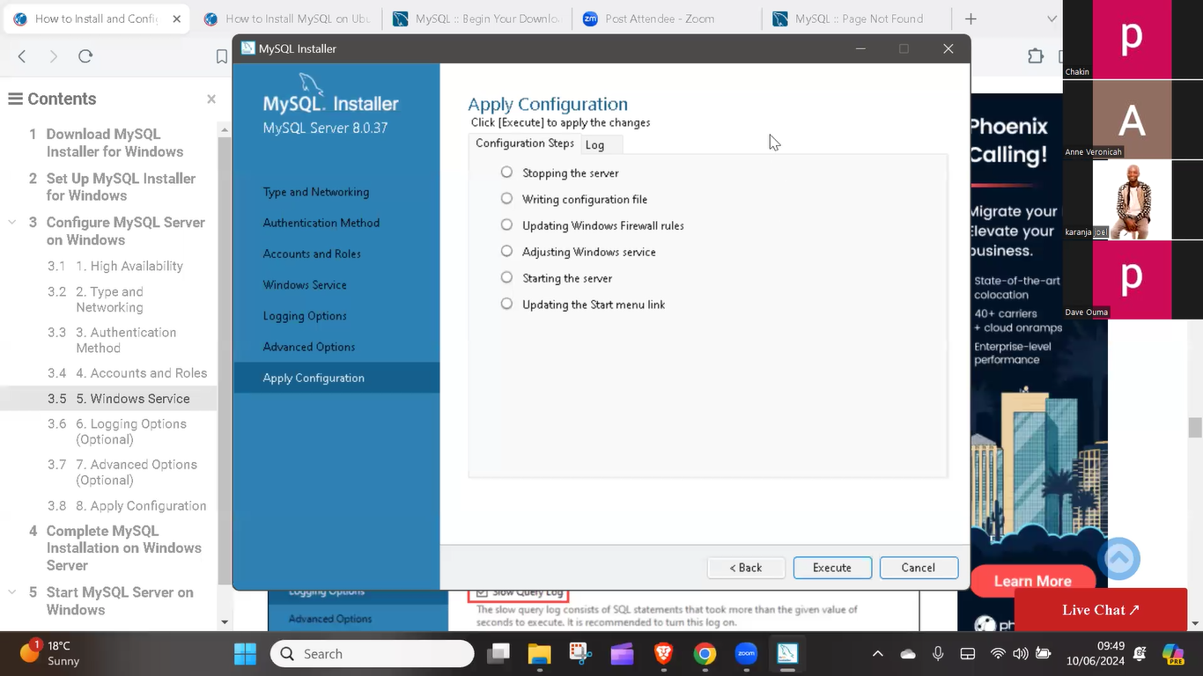

Step 13: Then I click “Execute” and it will install, after I clicked finished.

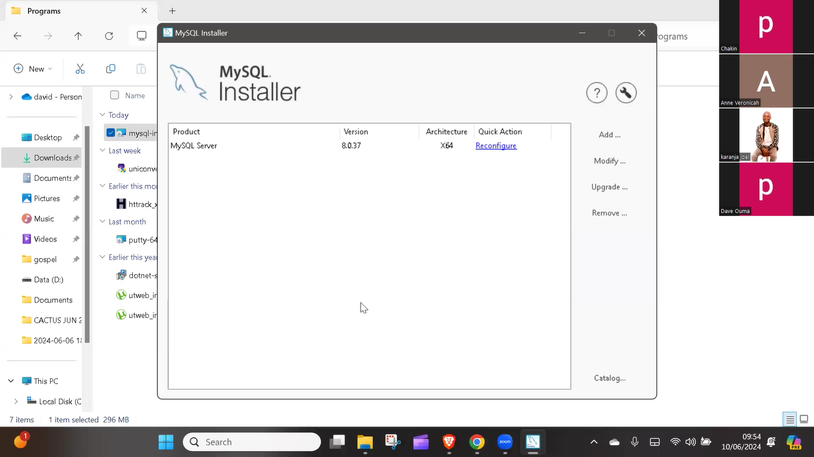

Step 14: All is done

Question 7

Set Up Development Environments and Virtualization (Optional): Consider using virtualization tools like Docker or virtual machines to isolate project dependencies and ensure consistent environments across different machines.

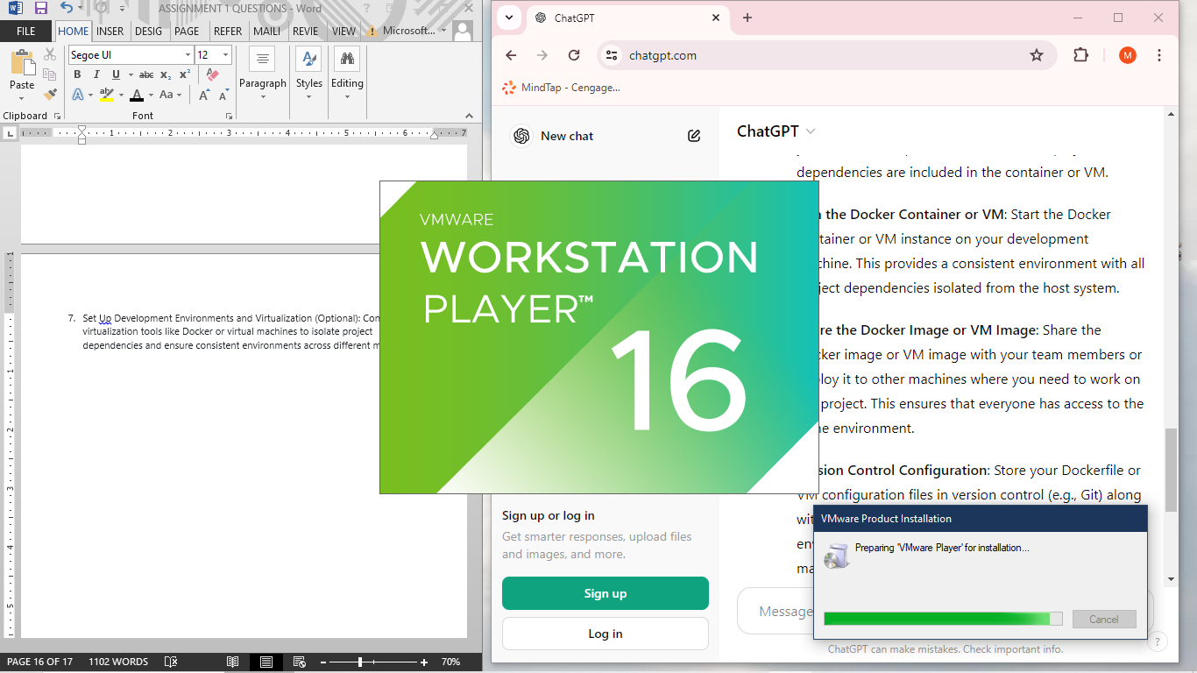

Step 1: I started by installing the application which led me to the setup wizard.

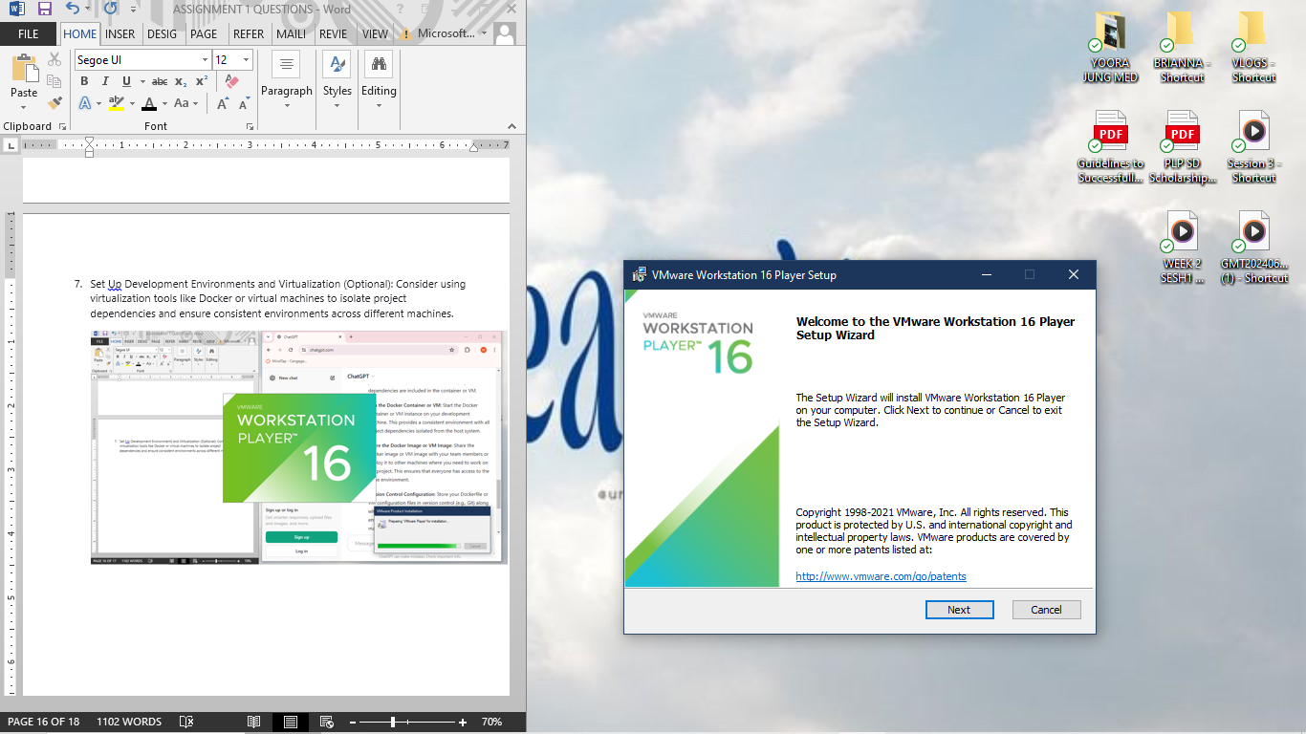

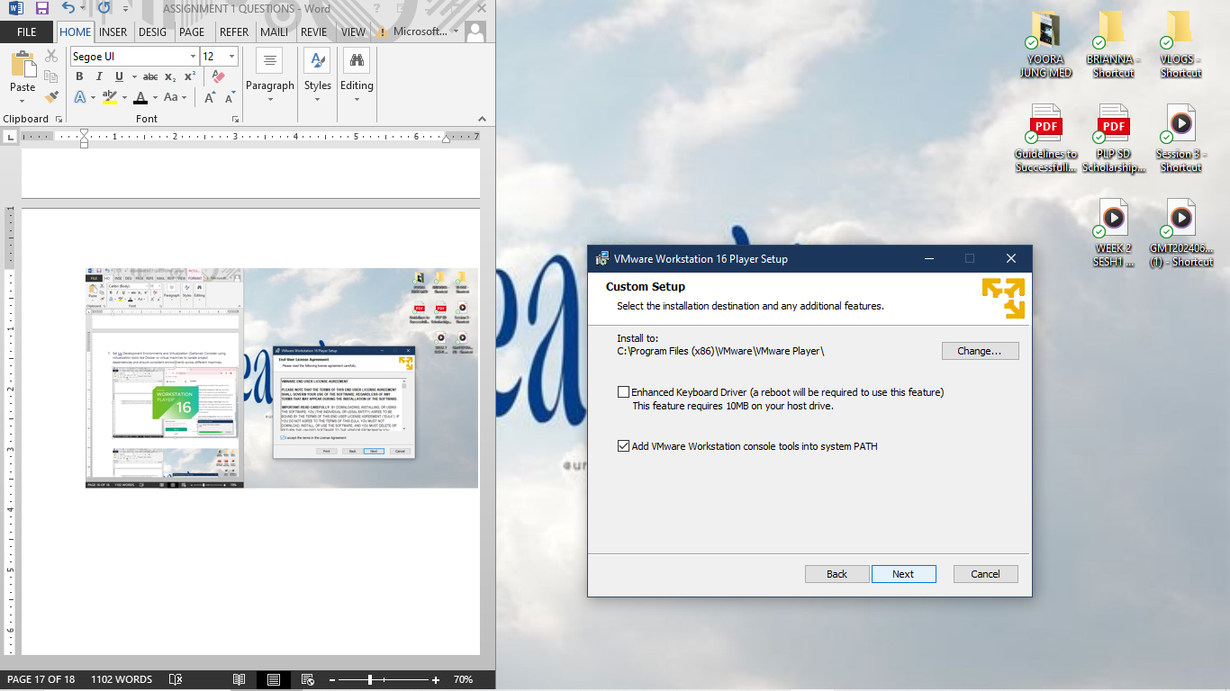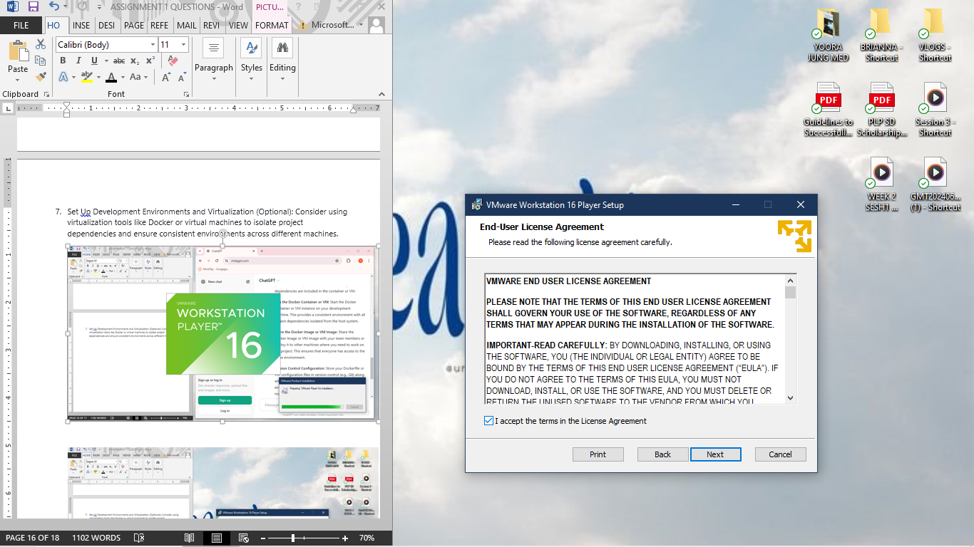Step 2: I ticked the boxes to install the VMware Workstation 16 Player.

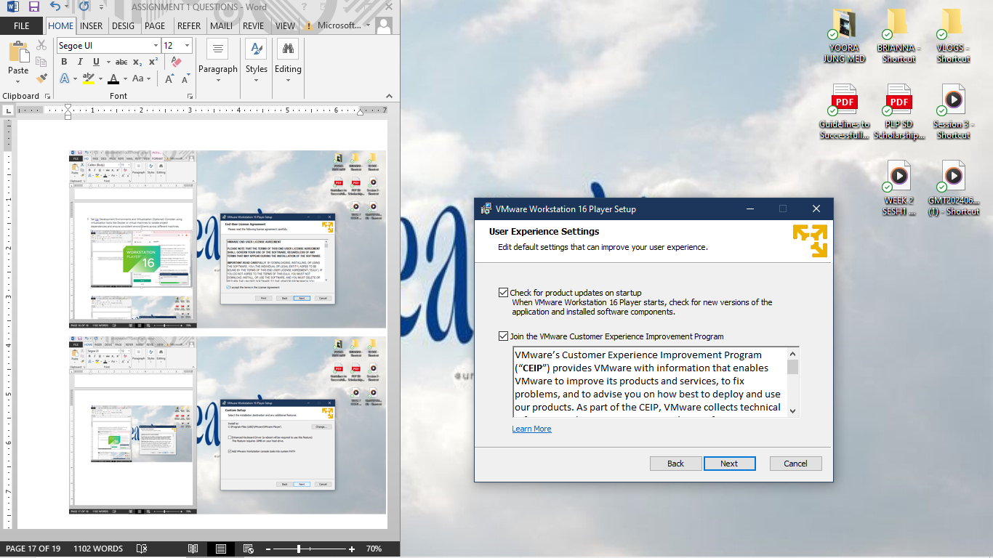

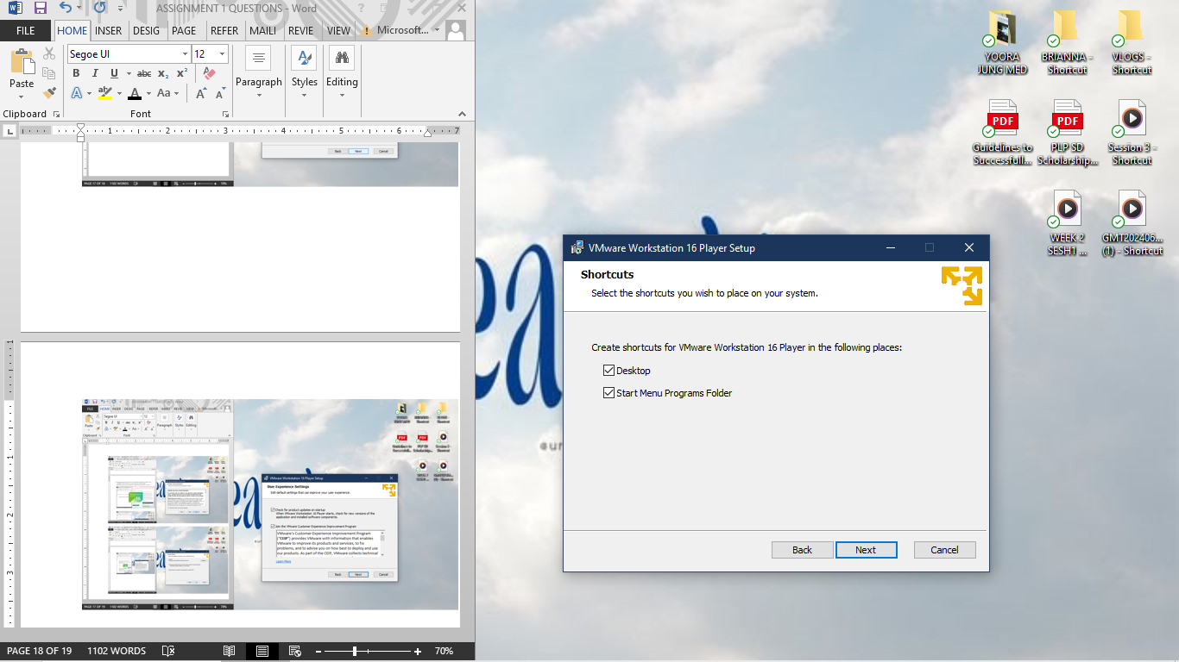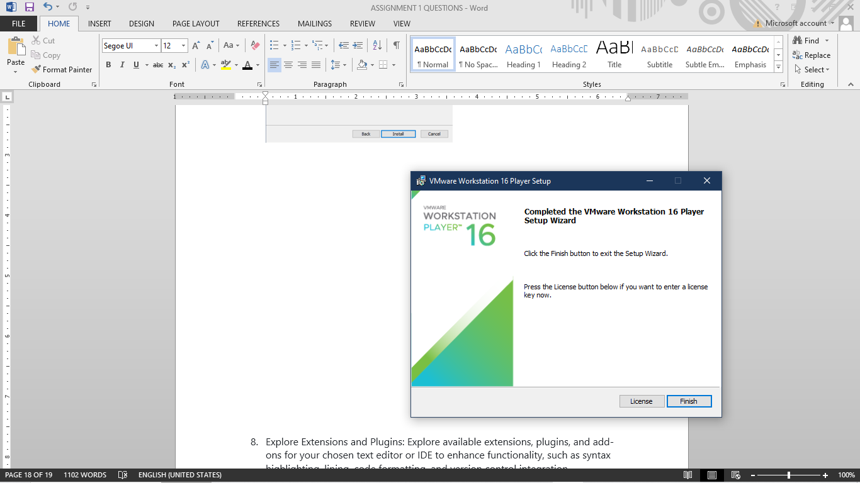

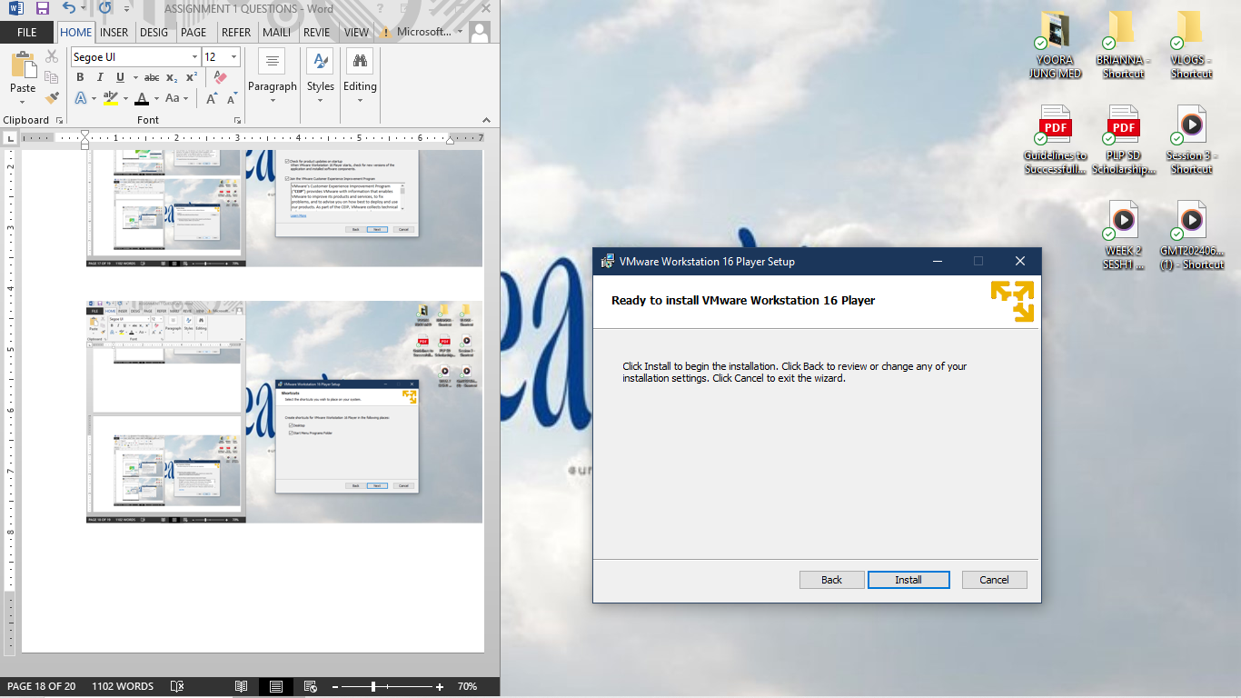

Step 3: All setup.

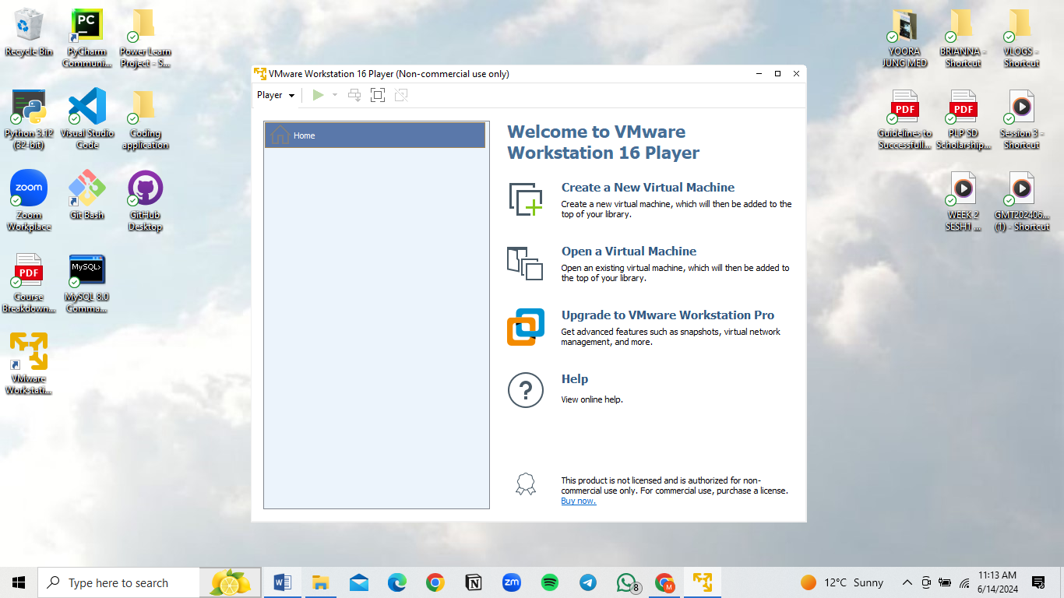

Step 4: Now using this application I Can open my Virtual machine or even make a new one for vitalization.

Question 8

Explore Extensions and Plugins: Explore available extensions, plugins, and add-ons for your chosen text editor or IDE to enhance functionality, such as syntax highlighting, lining, code formatting, and version control integration.

Here are some of the extensions used in my text editor which is VScode:

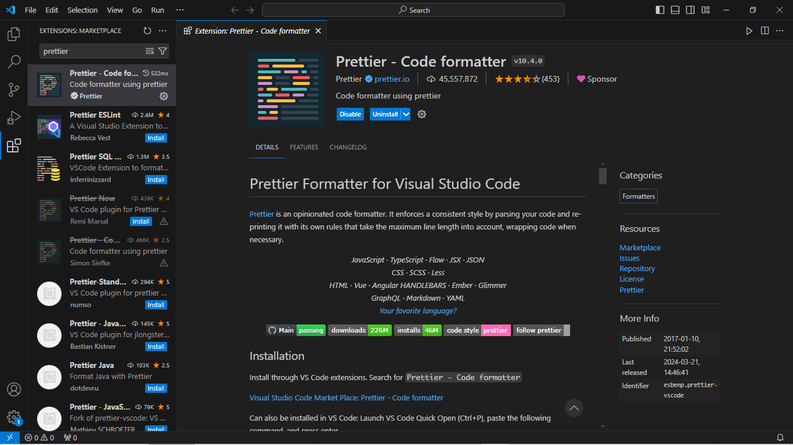Prettier:

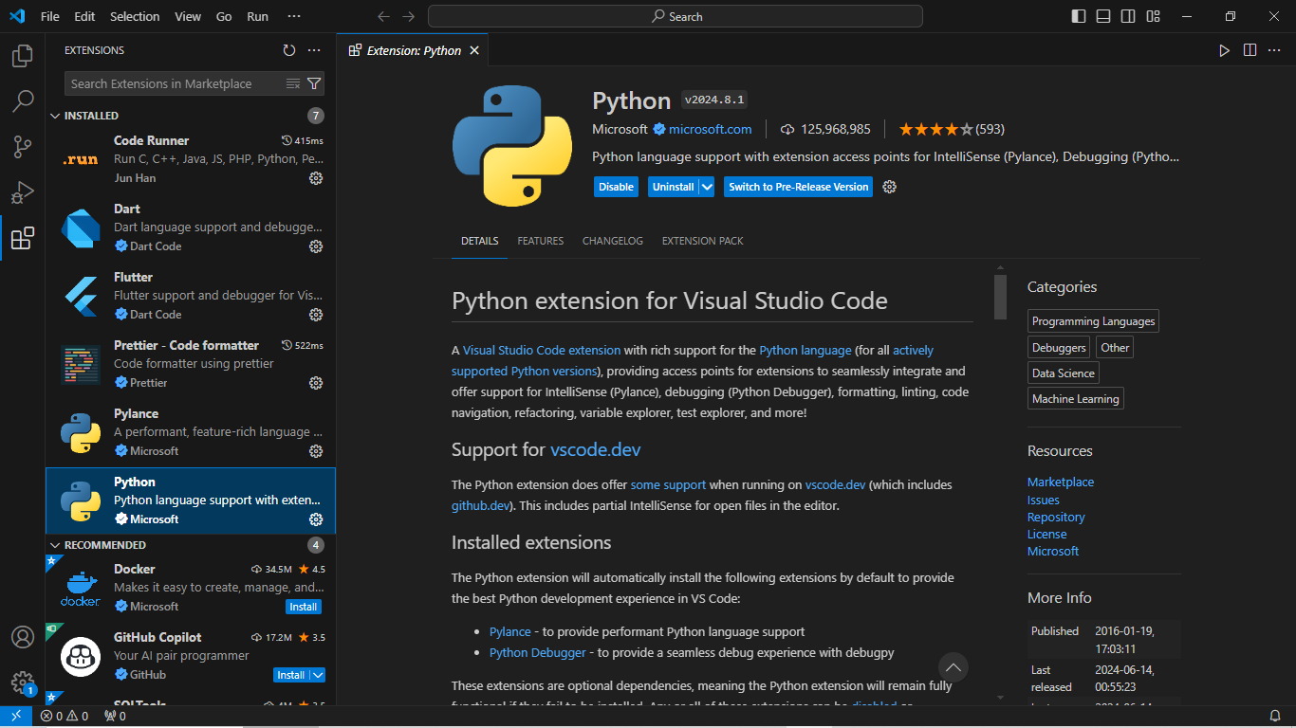Python:

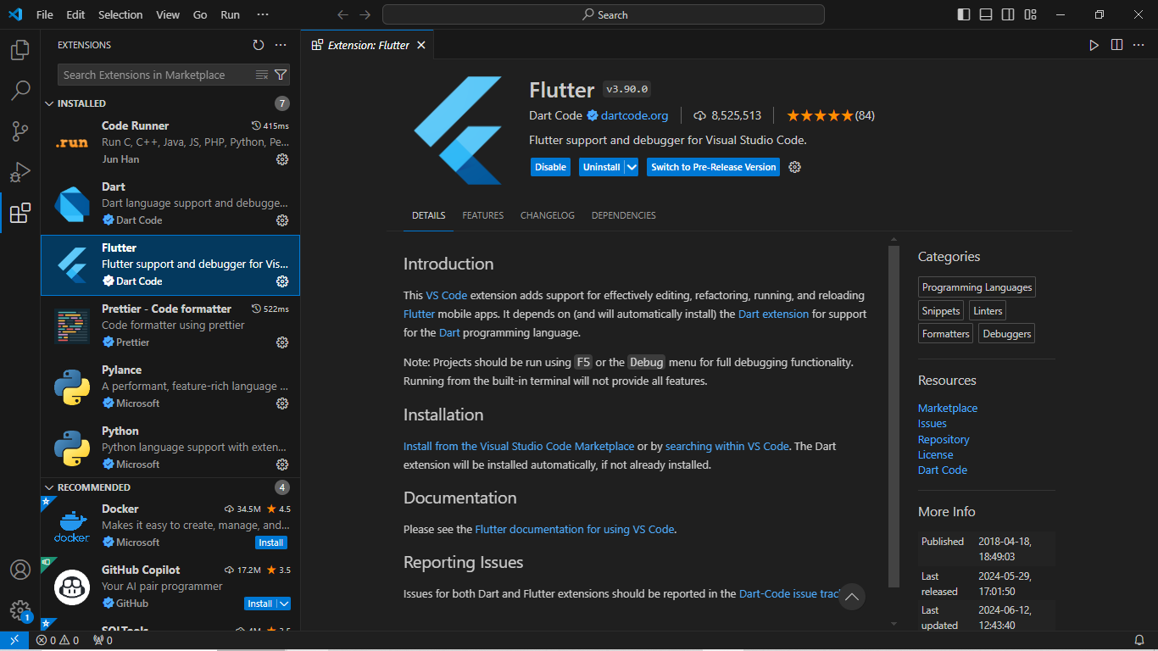Flutter:

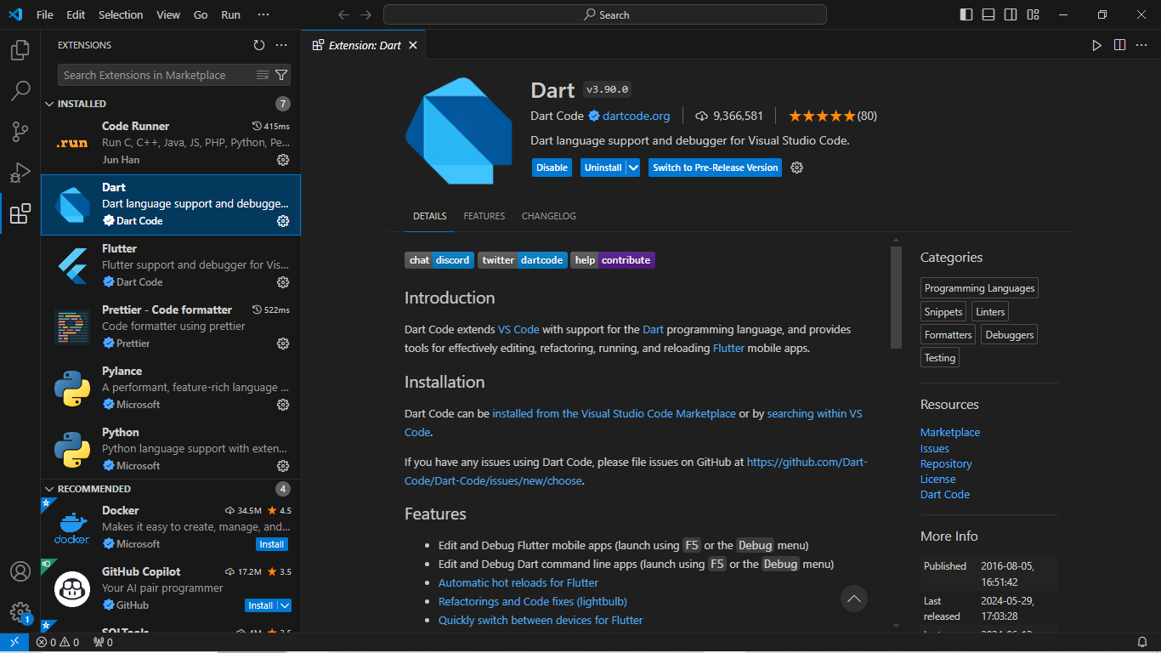Dart:

Code Runner:

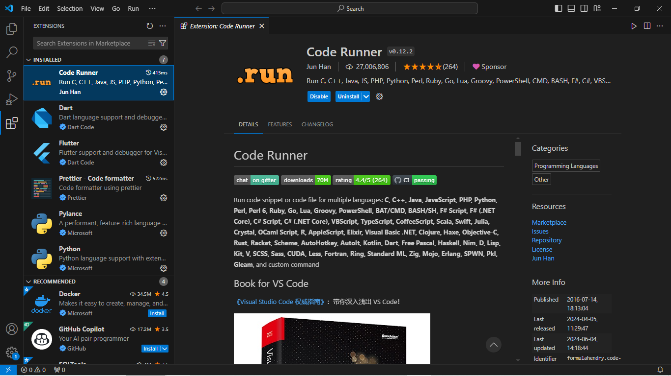

Question 9

Document Your Setup: Create a comprehensive document outlining the steps you've taken to set up your developer environment. Include any configurations, customizations, or troubleshooting steps encountered during the process.

Firstly we need to install my Developer environment which will be VScode, here are the steps below:

Step 1:

Click the link that was given therefore it will link you to the website “Visual Studio Code” Download page <https://code.visualstudio.com/Download>, if it doesn’t work, use your preferred browser and search “Download visual studio code” click on this image below:



Step 2:

Because my Operating System is Windows 10, I’ll then click on the blue box that has “Windows – Windows 10, 11” on it. It will automatically be downloaded



Step 3:

Click on open folder then on your downloads you will right click and “run as administrator”

Step 4:

Then it will lead you to the setup menu then you:



Step 5: Then you will click on” I accept button then “next”



Step 6: It will lead you to a next page which will have a default file path for you and then you just enter “Next”



Step 7: Select Smart Folder

Don’t click anything just Click “Next”.



Step 8: Select Additional Tasks

Tick all boxes then click “Next”.



Step 9: Ready to Install

Click “Install”



Step 10: After it has installed it will bring us to this page then click “Finish”



Step 11: Then the application will now launch

**Make workplace like creating a new python file on VScode (This is an example):**

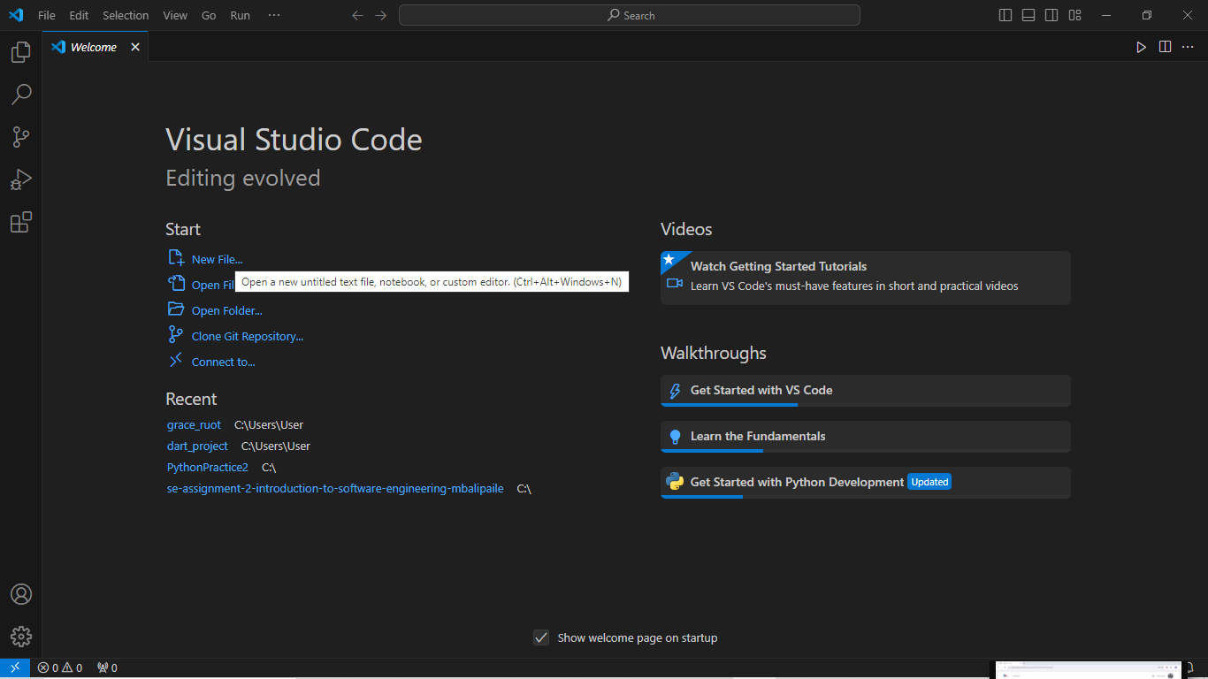

Step 1: Click on new file

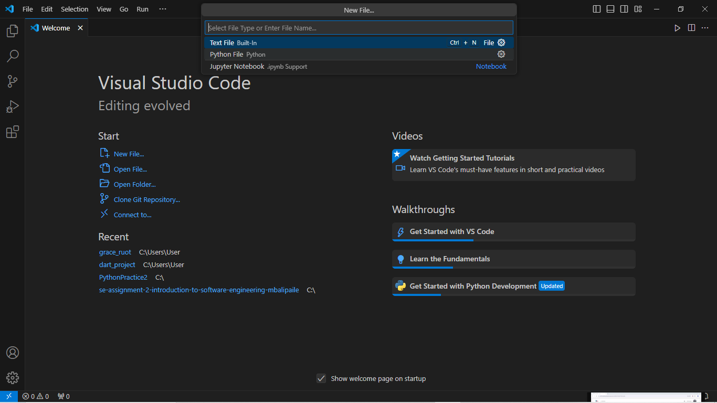

Step 2: Click the “Python File *Python*”

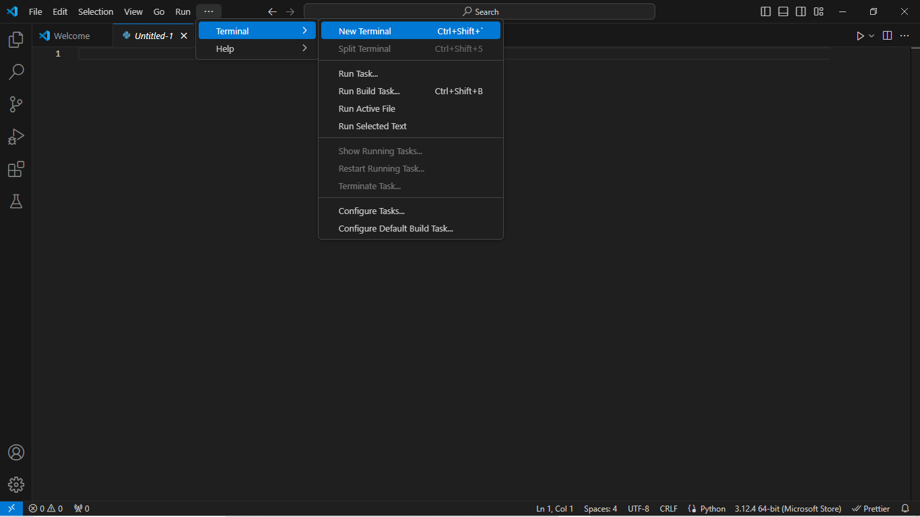

Step 3: After, click the three dotted icon above then click ”Terminal” after ”New Terminal”

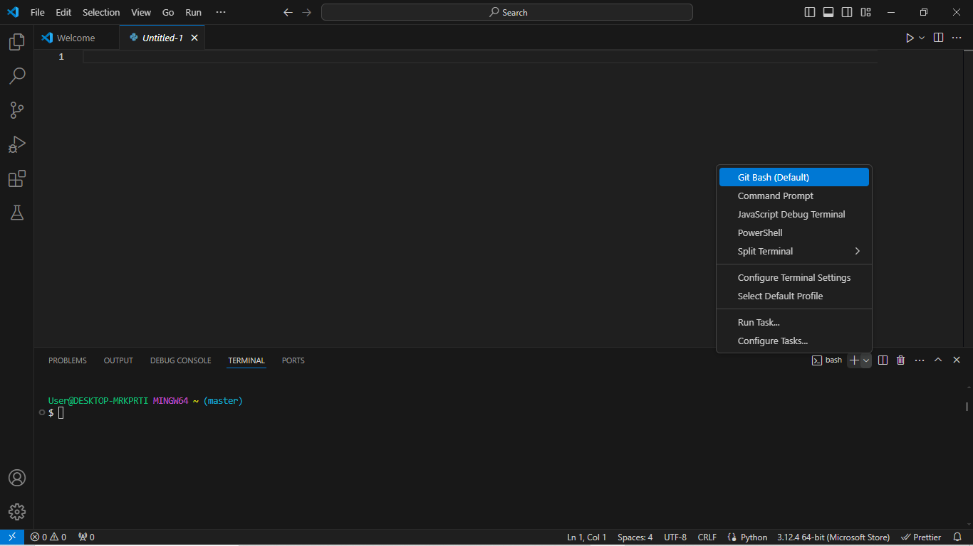

Step 4 go to the”+” sign on your terminal to choose on which terminal you will use.

**To get any additional Extensions, by using the steps below:**

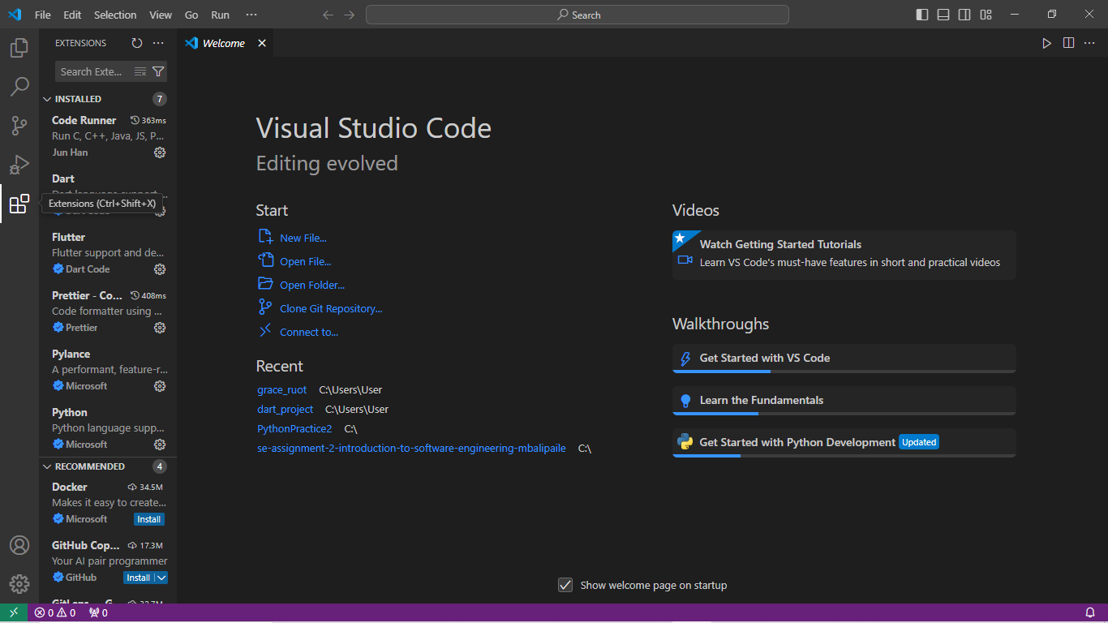

Once click on the Extensions icon tab, I get directed to the applications that I have installed. These are the few which are needed for future and current programming. For the language support I installed Python, JavaScript, Dart, Flutter etc.

There are even versions such as GitHub etc.

Here are examples of the few:

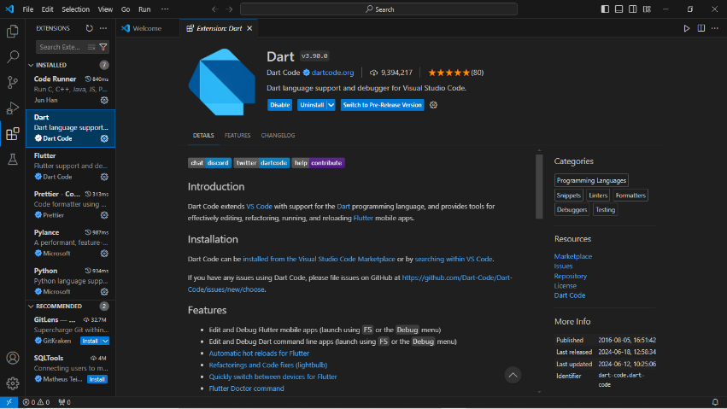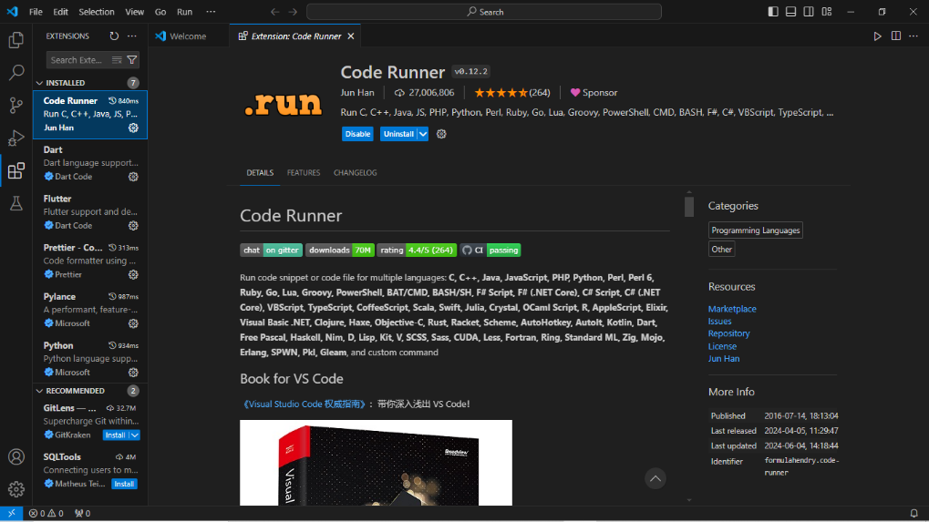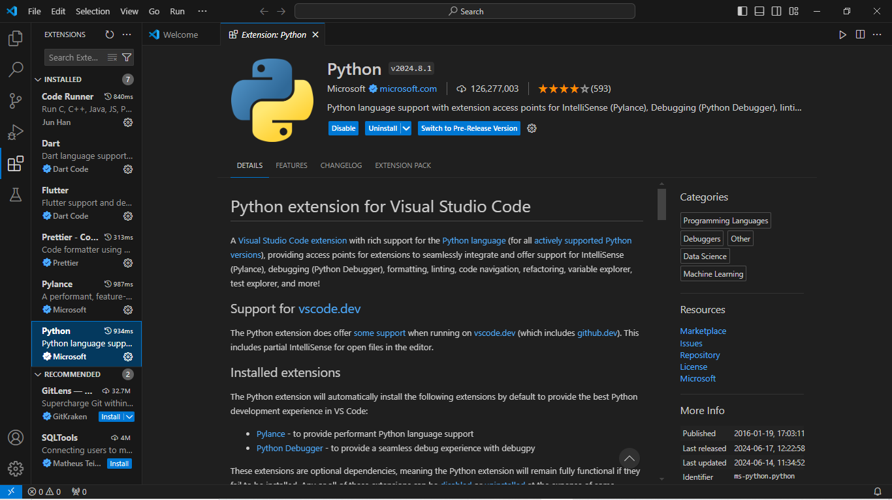

Now to configure or let VScode configure Git, you’ll do the following:

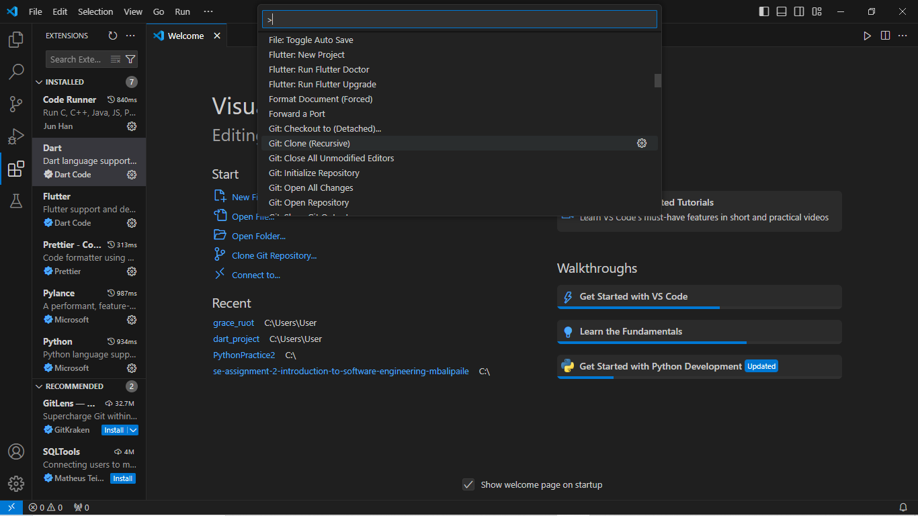

Step 1: Crl + Shift + P then click Git Clone on the search bar given as seen on the image above.

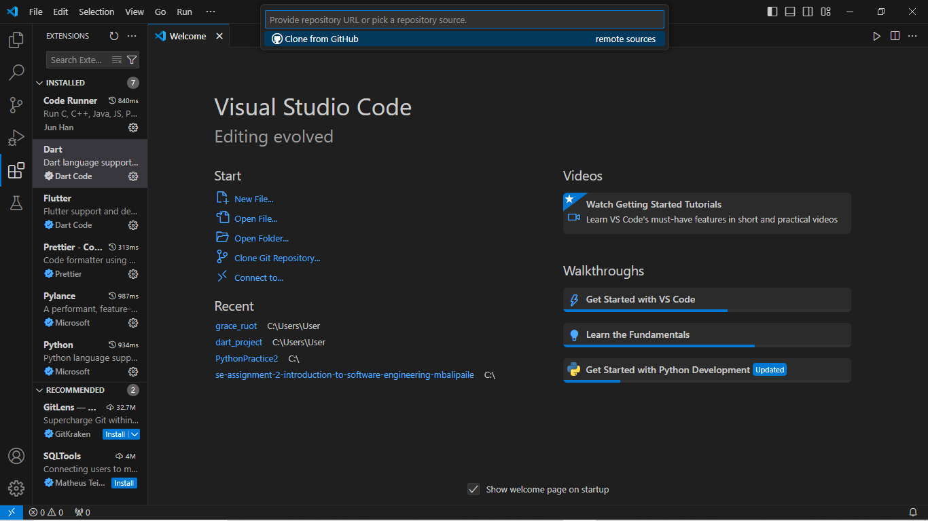Step 2: then click on “Clone from Github”

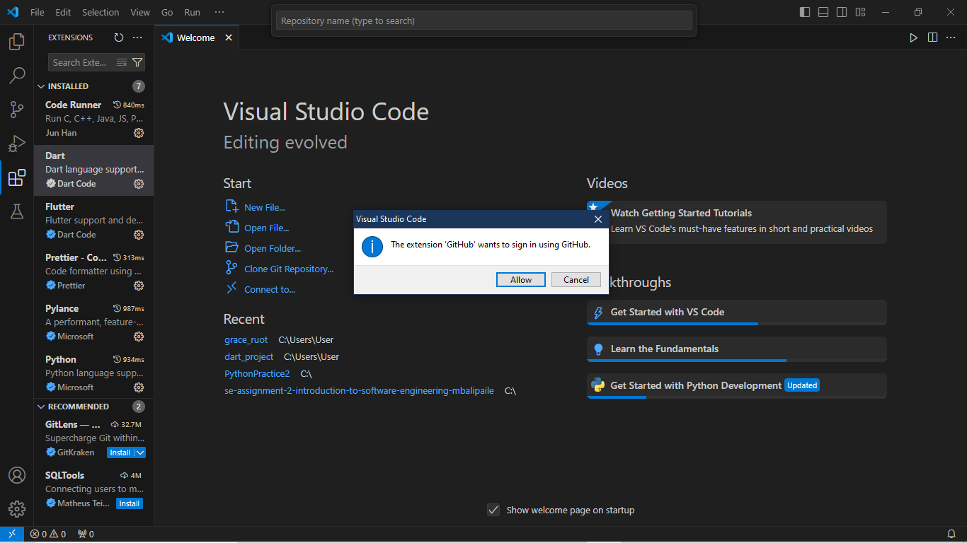

Step 3: Click allow

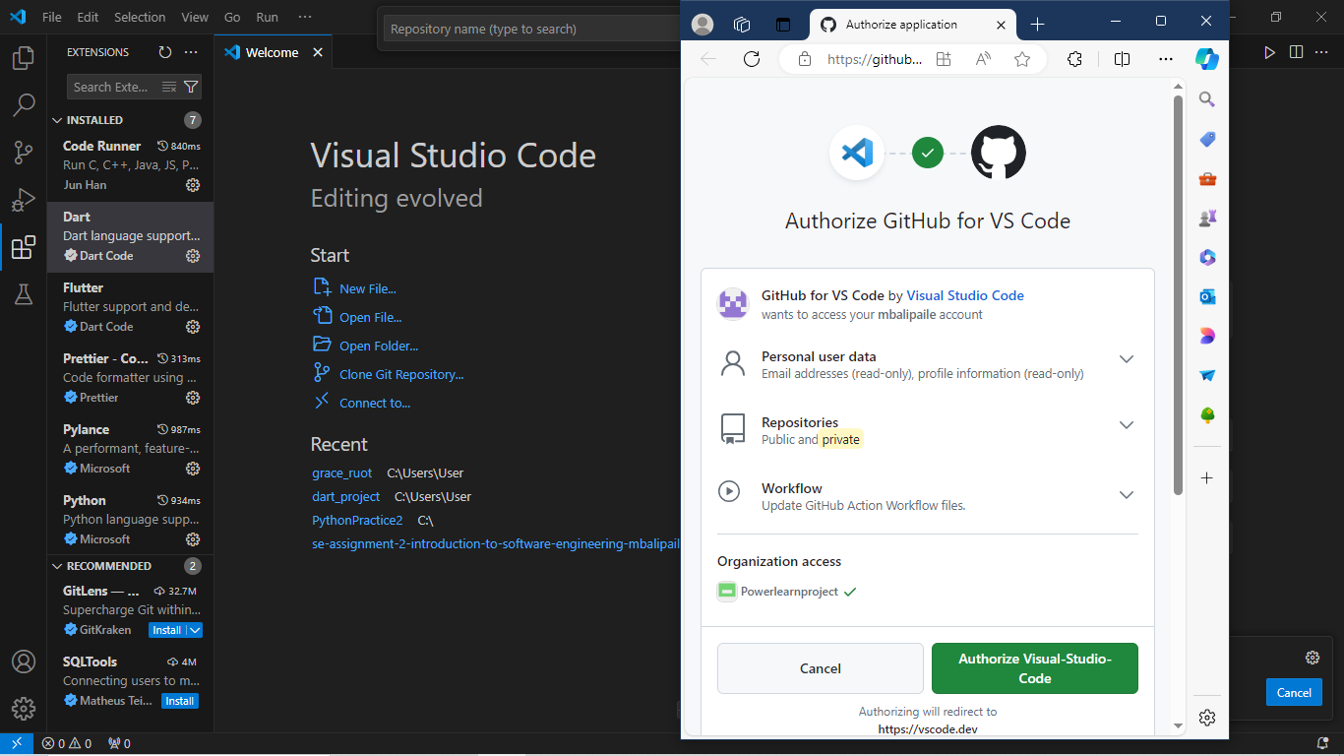

Step 4: After Authorizing you will now work with Git via your VScode.

For Troubleshooting, what I do most of the time if my VSCode isn’t working or is lagging I restart it or close it then open again so it is restarted.

Citation:

* *Download Windows 11* (no date). <https://www.microsoft.com/software-download/windows11> .
* *VS Code: Tips and tricks for beginners | MDN Blog* (2023). <https://developer.mozilla.org/en-US/blog/vs-code-tips-tricks/> .
* *MySQL :: Download MySQL Installer* (no date). <https://dev.mysql.com/downloads/windows/installer/5.7.html> .
* Python, R. (2023) *Python 3 Installation & Setup Guide*. <https://realpython.com/installing-python/>.
* Gangwar, M. (2024) *How to install Python on Windows 10*. <https://www.digitalocean.com/community/tutorials/install-python-windows-10> .
* *Git - Installing Git* (no date). <https://git-scm.com/book/en/v2/Getting-Started-Installing-Git> .